# K.J. Somaiya College of Science & Commerce Vidyavihar (E), Mumbai – 400077.

**Autonomous**

**Affiliated to University Of Mumbai**



**PROJECT REPORT ON**

E-LIBRARY MANAGEMENT SYSTEM

**SUBMITTED BY**

**DIPESH LAXMIDAS KHICHADA**

**T.Y.B.SC (COMPUTER SCIENCE)**

# UNIVERSITY OF MUMBAI 2020-2021

**PROJECT GUIDE MISS. KIRTI AMBERKAR**

K.J. Somaiya College of Science & Commerce

Vidyanagar, Vidyavihar, Mumbai – 400077. Autonomous – Affiliated to University Of Mumbai

## DEPARTMENT OF COMPUTER SCIENCE

**(2020-2021)**

CERTIFICATE

This is to certify that Mr. DIPESH KHICHADA of T.Y.B.Sc. [Computer Science] Semester –V, Seat no.2009819 has successfully

completed the project entitled as An E-Library Web Application to provide Online Books .

Level during the academic year 2020 – 2021.

Course coordinator B.Sc. (CS) Date:

|  |  |  |
| --- | --- | --- |
| Internal Guide | College Seal | External |
| Examiner |  |  |
| Date: |  | Date: |

**ACKNOWLEDGEMENT**

Achievement is finding out what you would be doing rather than what you have to do. It is not until you undertake such a project that you realize how much effort and hard work it really is, what your capabilities are and how well you present yourself or other things. It tells you how much we rely on the efforts and goodwill of others. It gives me immense pleasure to present this report towards the fulfillment of my project.

It has been rightly said that we are built on the shoulder of others. For everything I have achieved, the credit goes to all those who had helped me to complete this project successfully.

I take this opportunity to express my profound gratitude to management of K. J. Somaiya College of Science and Commerce for giving me this opportunity to accomplish this project work.

A special vote of thanks to my teachers, **Miss. Kirti Amberkar, Miss. Mousmi Pawar**

**,Miss.Suchita Mandhare, Mrs. Mohammad Bilal Shaikh and Miss. Monali Deshpande** for her most sincere, useful and encouraging contribution throughout the project span.

Finally I would like to thank all my friends(**Harsh Chheda**) and the entire Computer Science department who directly or indirectly helped me in completion of this project and to my family without whose support, motivation and encouragement this would not have been possible.

# INDEX

|  |  |  |
| --- | --- | --- |
| **SR. NO.** | **TOPIC** | **PAGE NO.** |
| 1 | Project overview | 6 |
| 2 | Description of System | 7 |
| 3 | Limitations of present system | 8 |
| 4 | Proposed system and its advantages | 9 |
| 5 | Stakeholders | 10 |
| 6 | Gantt chart | 11 |
| 7 | Technologies Used and their Description | 12 |
| 8 | Event Table | 14 |
| 9 | Use case Diagram and Basic Scenarios & Use Case Description | 15 |
| 10 | Entity-Relationship Diagram | 17 |
| 11 | Data Flow Diagram | 18 |
| 12 | Class Diagram | 19 |
| 13 | Sequence Diagram | 20 |
| 14 | State Diagram | 22 |
| 15 | Menu Tree | 23 |

|  |  |  |
| --- | --- | --- |
| 16 | List of Tables with Attributes and Constraints | 24 |
| 17 | System Coding | 25 |
| 18 | Screen Layouts and Report Layouts | 44 |
| 19 | Future Enhancements | 50 |
| 20 | Bibliography | 51 |

**PROJECT OVERVIEW**

This project is aimed at developing a web application for Online Library

Management System is a system which maintains the information

about the books present in the library, their authors, the members of library to

whom books are issued, library staff and all. This is very difficult to organize

manually. Maintenance of all this information manually is a very complex task.

Owing to the advancement of technology, organization of an Online Library

becomes much simple. The Online Library Management has been designed to

computerize and automate the operations performed over the information about

the members, book issues and returns and all other operations. This project

library helps in many instances of its maintenances. It reduces the workload of

management as most of the manual work done is reduced

# PRESENT SYSTEM

# E-Library Management System is an application which refers to library systems which are generally small or medium in size. It is used by Admin to manage the library using a computerized system where he/she can add new books, Author and Publisher.

# Books and student maintenance modules are also included in this system which would keep track of the students using the library and also description about the books a library contains. With this computerized system there will be no loss of book record or member record which generally happens when a physical system is used.

# All these modules are able to help librarian to manage the library with more convenience and in a more efficient way as compared to library systems which is virtual.

# LIMITATIONS OF PRESENT SYSTEM

# 

# The feature for getting free pdf to read online so that any one can access it can be added in view books module.

# Also one can add Review Rating Feature where books can be reviewed.

# Search filter also can be added to get specified result or required.

# Audio Module can be added for keen listener

# Microphone based search technology can be added.

# Download pdf for free books can be made available

# 

# PROPOSED SYSTEM AND ITS ADVANTAGES

The students will register them through Online

Individually each member will have his account through which he can access the

information he needs.

Book details like authors, number of copies totally maintained by library, present

available number of books, reference books, non-reference books etc. all this

information can be made handy.

Regarding the members designation, number of books was issued.

Issue dates and returns of each member is maintained separately and fine charged

if there is any delay in returning the book.

## ADVANTAGE:

1.Admin

Admin has only rights so if user misbehaves admin can de-active user.

2.Fond Awesome Button

On click of button action can be performed

Example On Click of Go Button All Database values get fetched and textbox values gets filled Automatically

# STAKEHOLDERS

A stakeholder is either an individual, group or organization who is impacted by the outcome of

a project. They have an interest in the success of the project, and can be within or outside the

organization that is sponsoring the project.

Following are the stakeholders for the project

1. Developer

Developer is the main person of the system. Developer knows all the information about

the system. Developer deals with managing the user records.

2. User

User is the one who uses this application to get benefits from the application. Example:-

Student, Teachers etc

# GANTT CHART

A Gantt chart, commonly used in project management, is one of the most popular and useful ways of showing activities (tasks or events) displayed against time. On the left of the chart is a list of the activities and along the top is a suitable time scale. Each activity is represented by a bar; the position and length of the bar reflects the start date, duration and end date of the activity.

# TECHNOLOGIES USED AND THEIR DESCRIPTION

## SOFTWARE:

1. **Microsoft SQL:** It is a relational database management system. As a database it‘s a software product whose primary function is to store & retrieve data as requested by other software applications, be it those on the same computer or those running on another computer across a network (including the internet).
2. **Microsoft Visual Studio:** Is an integrated development environment (IDE) from Microsoft. It is used to develop computer programs, as well as websites, web apps, web services and mobile apps. Visual Studio uses Microsoft software development platforms such as Windows API, Windows Forms, Windows Presentation Foundation, Windows Store and Microsoft Silverlight. It can produce both native code and managed code.

Visual Studio includes a code editor supporting IntelliSense (the code completion component) as well as code refactoring. The integrated debugger works both as a source-level debugger and a machine-level debugger. Other built-in tools include a code profiler, forms designer for building GUI applications, web designer, class designer, and database schema designer. It accepts plug-ins that enhance the functionality at almost every level—including adding support for source control systems (like Subversion and Git) and adding new toolsets like editors and visual designers for domain-specific languages or toolsets for other aspects of the software development lifecycle (like the Team Foundation Server client: Team Explorer).

C) **Fond Awesome Icon**: Font Awesome is a font and icon toolkit based on CSS and Less. It was made by Dave Gandy for use with Bootstrap, and later was incorporated into the Bootstrap CDN. Font Awesome has a 38% market share among those websites that use third-party font scripts on their platform, ranking it second place after Google Fonts.

D) **Boot Strap:**

Bootstrap 4 is the newest version of [Bootstrap](https://www.w3schools.com/bootstrap/default.asp), which is the most popular HTML, CSS, and JavaScript framework for developing responsive, mobile-first websites.

# EVENT TABLE

**Member Table**

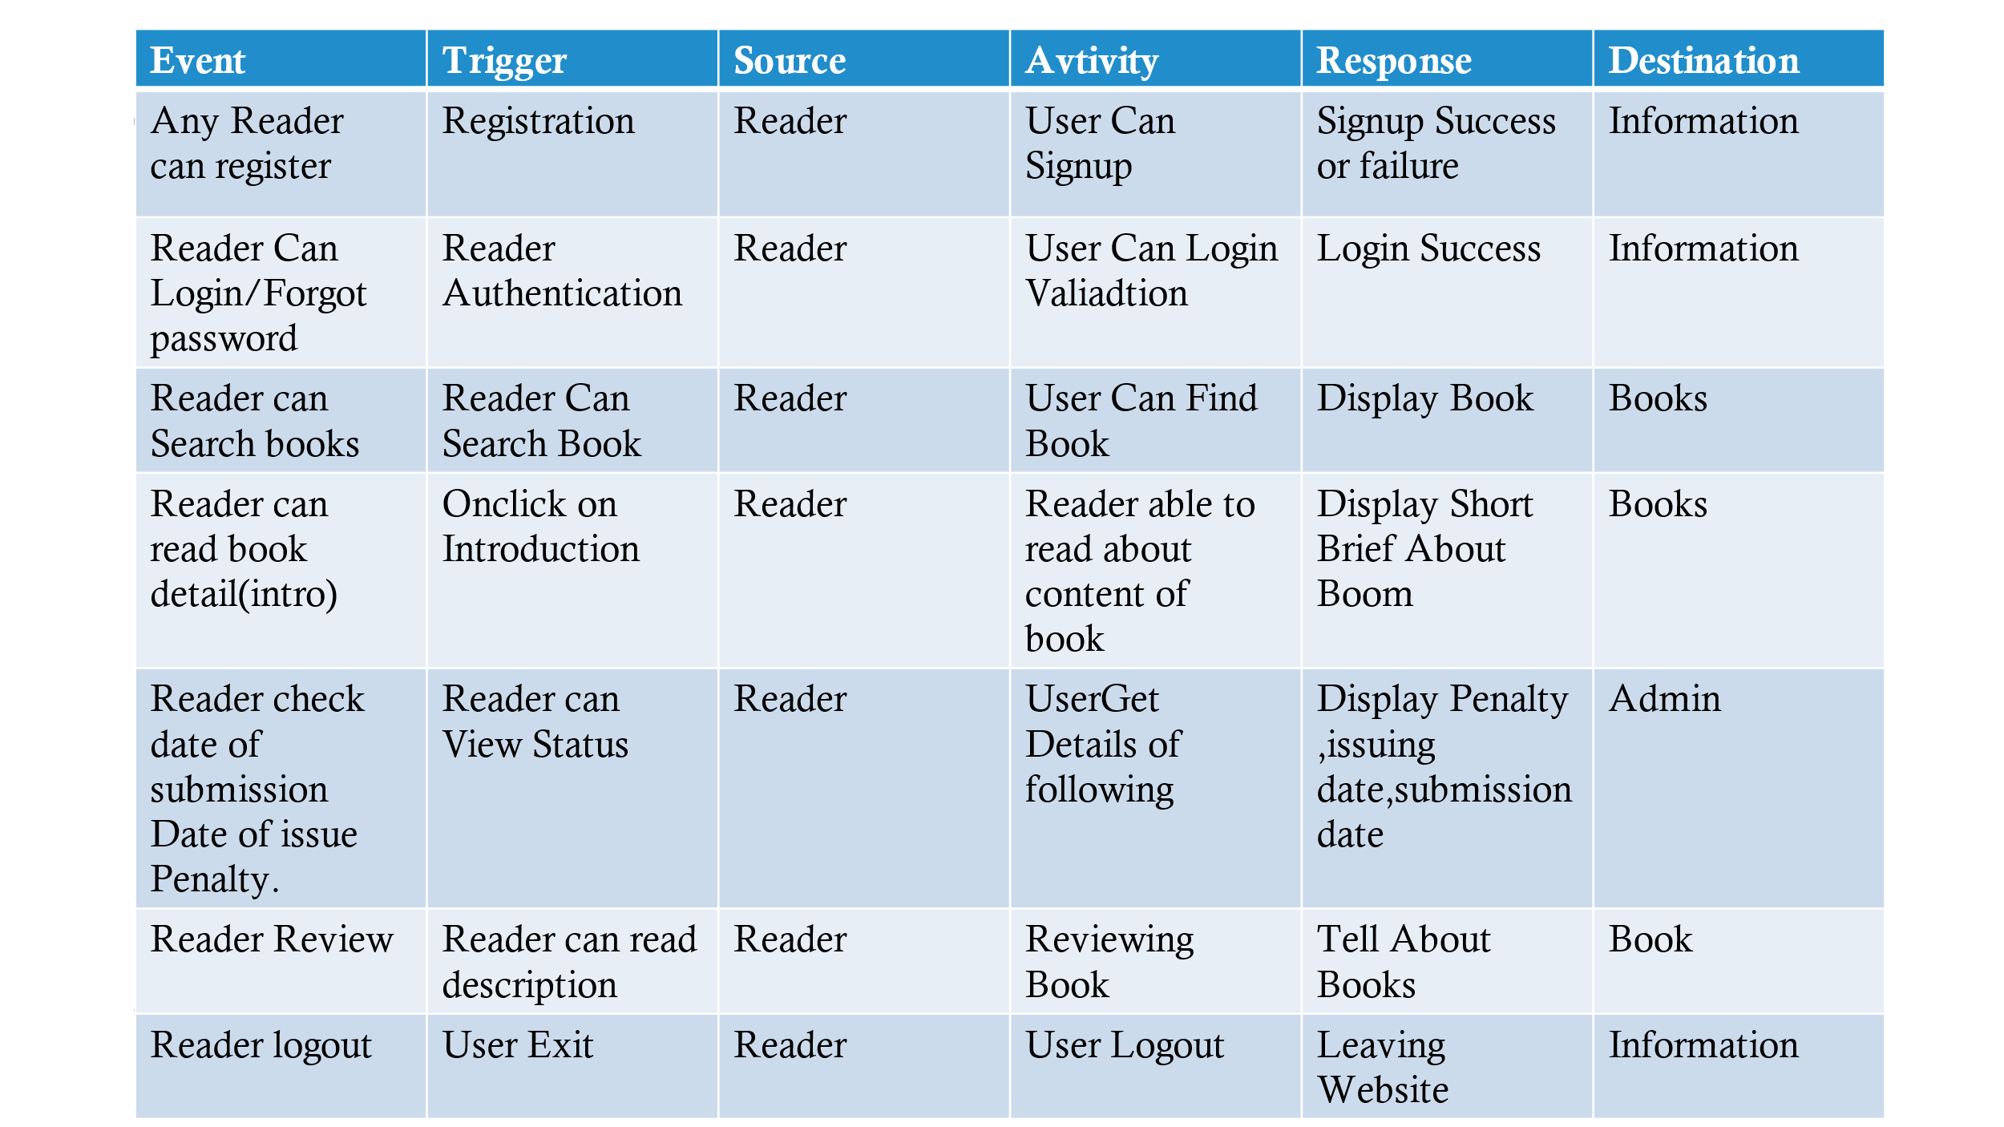

**Administrator:**

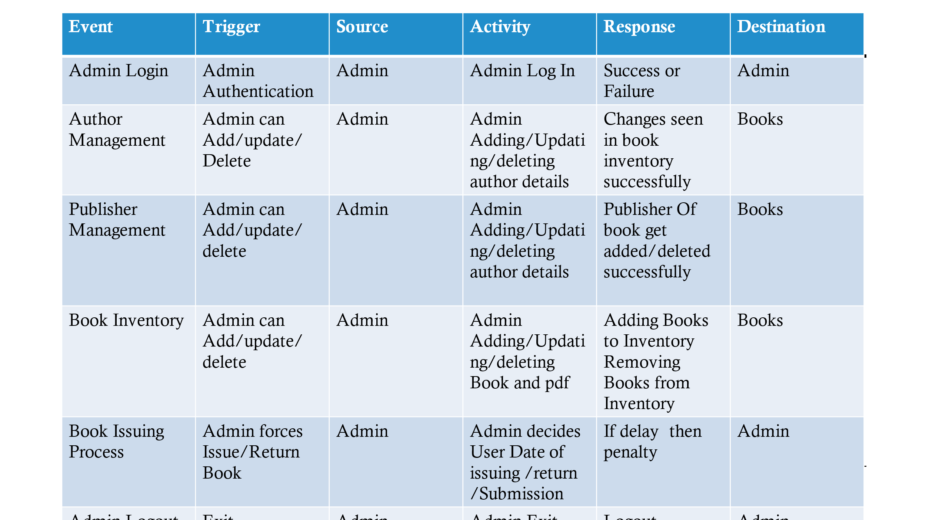

**USE CASE DIAGRAM AND BASIC SCENARIOS & USE CASE DESCRIPTION**

A Use case is a description of set of sequence of actions graphically it is rendered as an ellipse with solid line including only its name. Use case diagram is a behavioral diagram that shows a set of use cases and actors and their relationship. It is an association between the use cases and actors. An actor represents a real-world object.

# USE CASE DIAGRAM FOR E-LIBRARY MANAGEMENT

# 

**ENTITY-RELATIONSHIP DIAGRAM**

An Entity Relationship Diagram (ERD) is a graphical tool to express the overall structure of a database. It is based on a perception of a real world which consists of a set of basic objects.

An entity is a person, place, thing or event of interest to the organization and about which

Data are captured, stored or processed. The attributes are various kinds of data that describes an entity. An association of several entities in an Entity-Relationship model is called relationship

An ERD consists of the following major components: Rectangles: Used for representing entity types

Ellipses: Used for representing attribute

Diamond: Used for representing relationship types

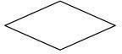

Lines: Used for linking attributes to entity types



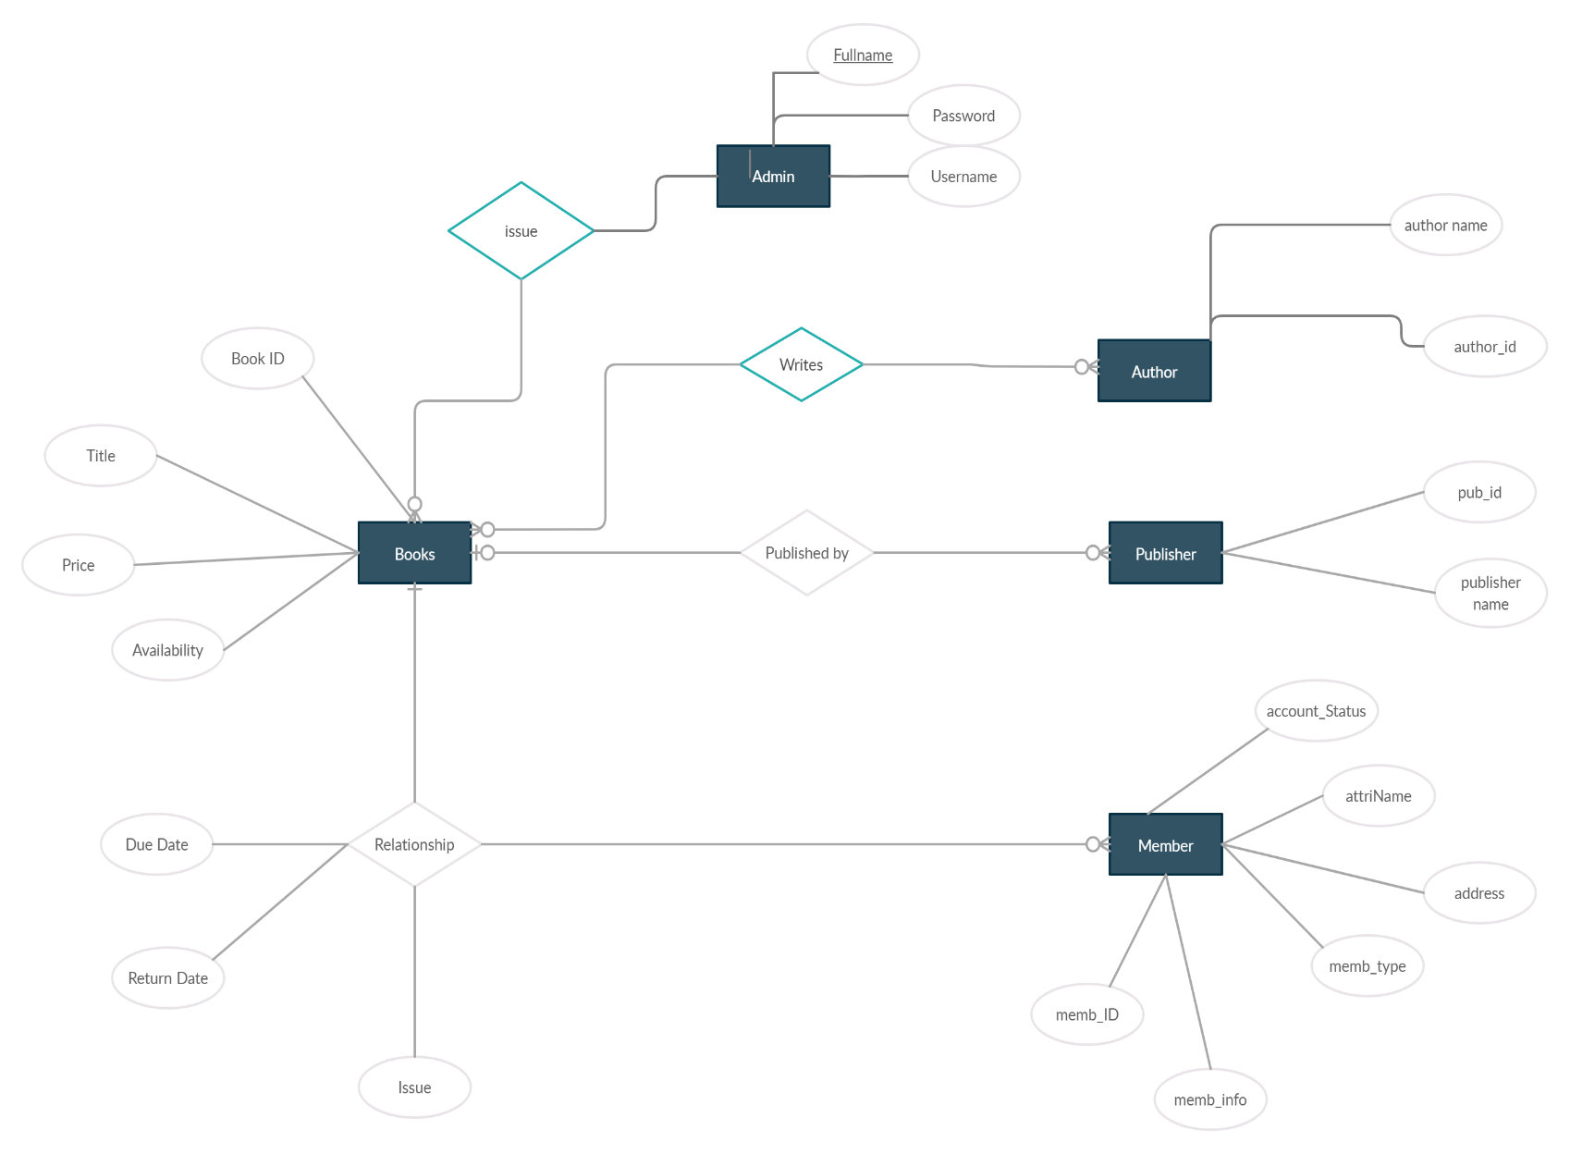

# DATA FLOW DIAGRAM

# A data flow diagram (DFD) maps out the flow of information for any process or system. It uses defined symbols like rectangles, circles and arrows, plus short text labels, to show data inputs, outputs, storage points and the routes between each destination.

DFD level 0:

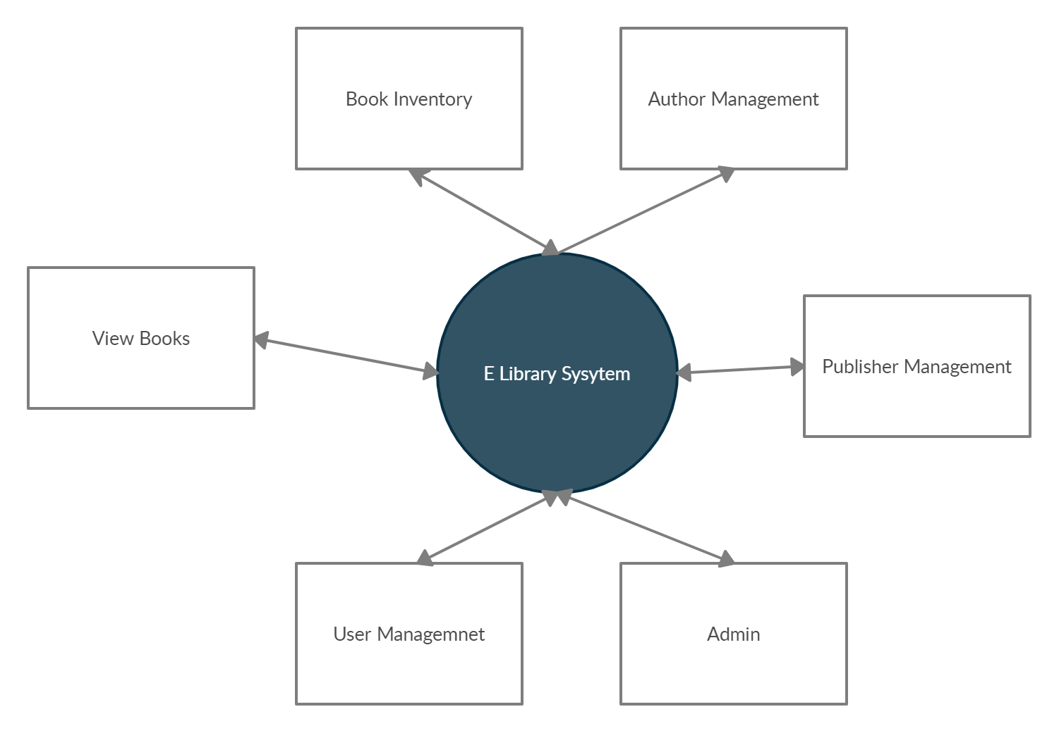

DFD level 1:

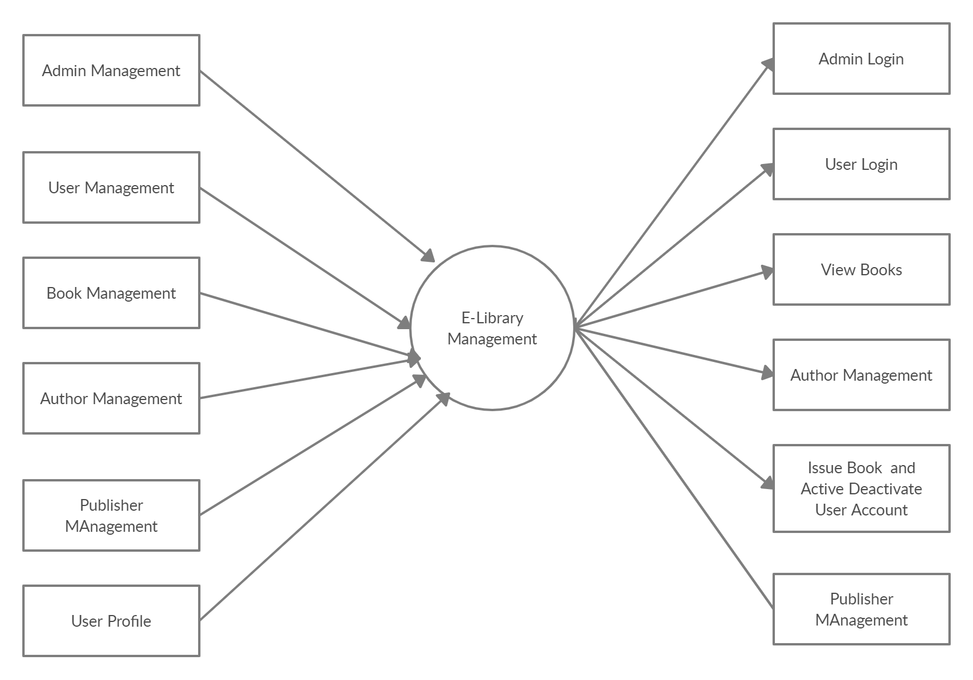

# DFD LEVEL 2:

# 

# CLASS DIAGRAM

# A class diagram in the Unified Modeling Language is a type of static structure diagram that describes the structure of a system by showing the system's classes, their attributes, operations, and the relationships among objects.

# 

**SEQUENCE DIAGRAM**

Sequence diagram and collaboration diagram are called INTERACTION DIAGRAMS. An interaction diagram shows an interaction, consisting of set of objects and their relationship including the messages that may be dispatched among them.

A sequence diagram is an introduction that empathizes the time ordering of messages. Graphically a sequence diagram is a table that shows objects arranged along the X-axis and messages ordered in increasing time along the Y-axis

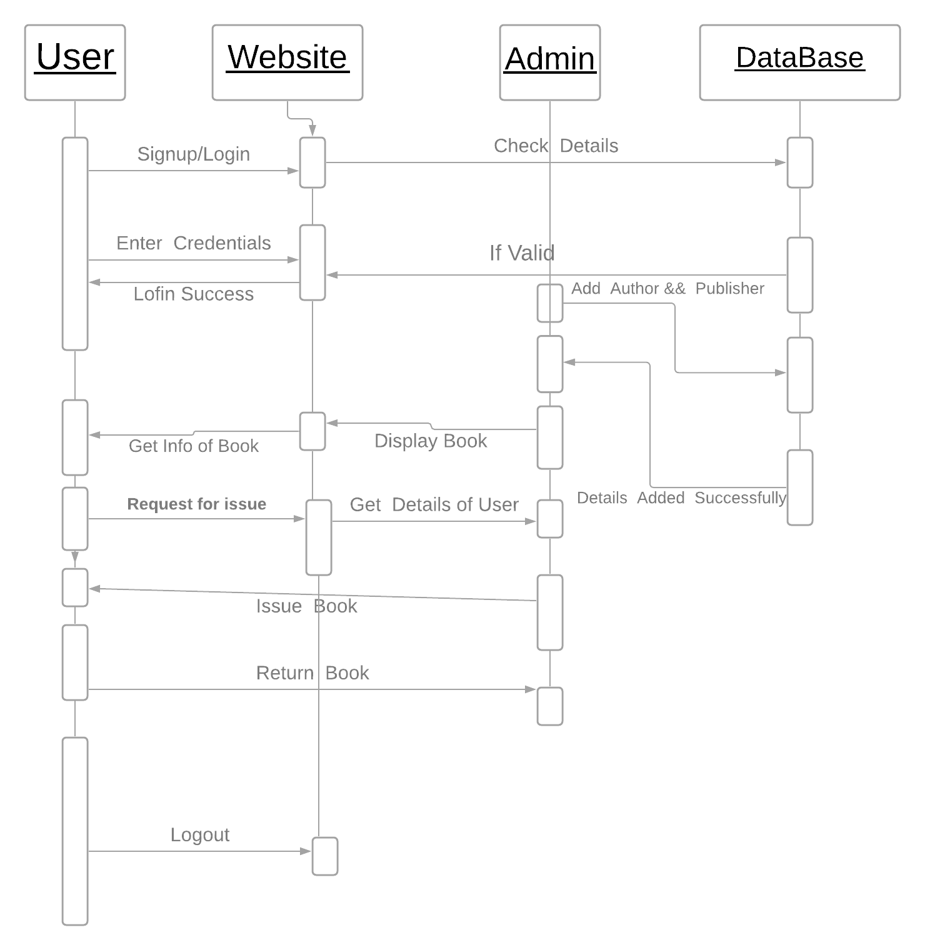

**Activity Diagram**

A) Activity for Admin

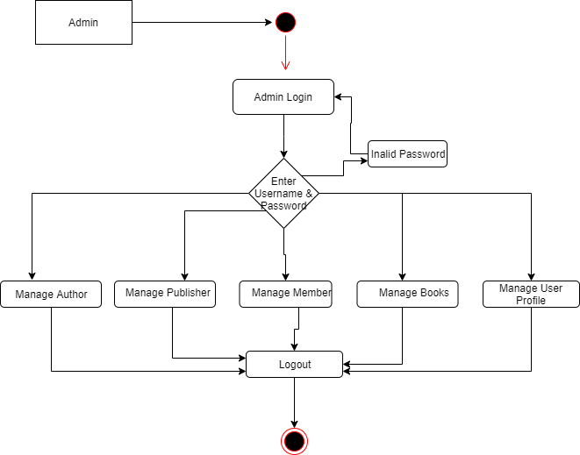

B) Activity for User

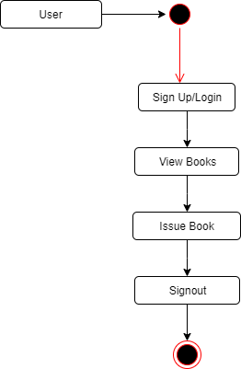

# State Diagram

# State chart diagram is also called as state machine diagram. The state chart diagram contains the states in the rectangular boxes and the states are indicated by the dot enclosed. The state chart diagram describes the behavior of the system. The state chart diagram involves stages such as login, enter details, requesting for book, display book details, issue

# book, return book and logout.

(A) **State Diagram For User**

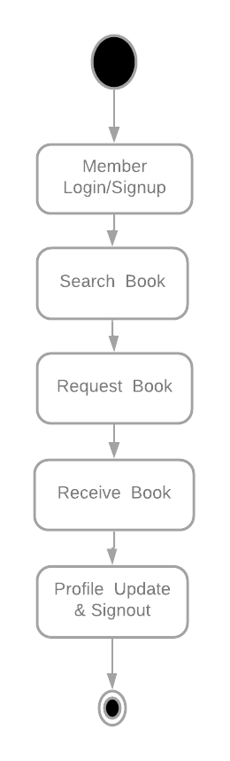

B) Admin State Diagram

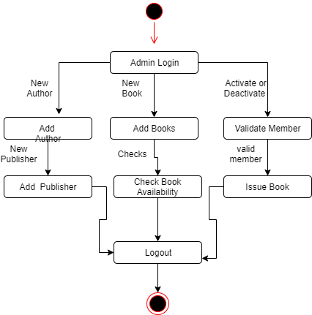

# MENU TREE

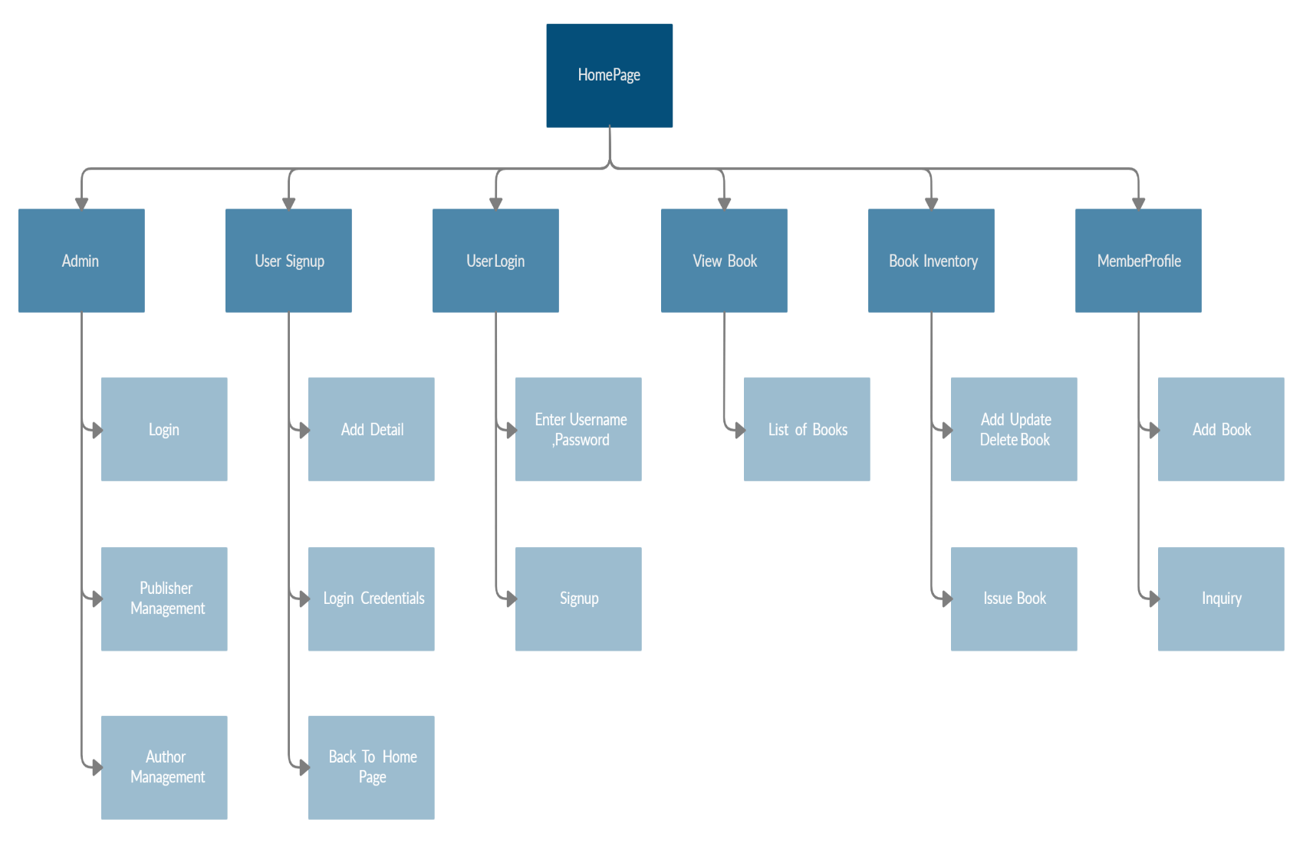

**LIST OF TABLES WITH ATTRIBUTES AND CONSTRAINTS**

1. Member Table:

|  |  |  |  |
| --- | --- | --- | --- |
| **Column** | **Type** | **Null** | **Key** |
| Full Name | Character | No |  |
| Dob | Varchar | No |  |
| Email | Varchar | No |  |
| State | Varchar | No |  |
| City | Varchar | No |  |
| Pin code | Varchar | No |  |
| Full Address | Varchar | No |  |
| Member id | Varchar | No | Primary Key |
| Password | Varchar | No |  |
| Account Status | Varchar | No |  |

(B)Admin Table:

|  |  |  |  |
| --- | --- | --- | --- |
| **Column** | **Type** | **Null** | **Key** |
| User Name | Character | No | Primary |
| Password | Varchar | No |  |

1. Book Table:

|  |  |  |  |
| --- | --- | --- | --- |
| **Column** | **Type** | **Null** | **Key** |
| Book ID | Integer | No | Primary Key |
| Book Name | Varchar | No |  |
| genre | Varchar | No |  |
| Author Name | Character | No | Foreign Key |
| Publisher Name | Character | No | Foreign Key |
| Publish Date | Date | No |  |
| Language | Varchar | No |  |
| Edition | Integer | No |  |
| Book Cost | Integer | No |  |
| No of Pages | Integer | No |  |
| Book  Description | Varchar | No |  |
| Actual Cost | Integer | No |  |
| Current Cost | Integer | No |  |
| Book Image | Varchar | No |  |

(D) Author Table

|  |  |  |  |
| --- | --- | --- | --- |
| **Column** | **Type** | **Null** | **Key** |
| Author Id | Character | No | Primary |
| Author Name | Varchar | No |  |

# (E) Publisher Table

|  |  |  |  |
| --- | --- | --- | --- |
| **Column** | **Type** | **Null** | **Key** |
| Publisher Id | Character | No | Primary |
| Publisher Name | Varchar | No |  |

# (F) Book Issue Table

|  |  |  |  |
| --- | --- | --- | --- |
| **Column** | **Type** | **Null** | **Key** |
| Member Id | Character | No | Foreign |
| Member Name | Varchar | No |  |
| Book Id | Varchar | No | Foreign |
| Book Name | Varchar | No |  |
| Issue Date | Varchar | No |  |

# CODE

* 1. **Site1.Master**

<%@ Master Language="C#" AutoEventWireup="true" CodeBehind="Site1.master.cs" Inherits="WebApplication1.Site1" %>

<!DOCTYPE html>

<html>

<head runat="server">

<title></title>

<%--bootstrap css--%>

<link href="bootstrap/css/bootstrap.min.css" rel="stylesheet" />

<%--datatables css--%>

<link href="datatables/css/jquery.dataTables.min.css" rel="stylesheet" />

<%--fontawesome css--%>

<link href="fontawesome/css/all.css" rel="stylesheet" />

<%--our custom css--%>

<link href="css/customstylesheet.css" rel="stylesheet" />

<%--jquery--%>

<script src="bootstrap/js/jquery-3.3.1.slim.min.js"></script>

<%--popper js--%>

<script src="bootstrap/js/popper.min.js"></script>

<%--bootstrap js--%>

<script src="bootstrap/js/bootstrap.min.js"></script>

<%--Datatables js--%>

<script src="datatables/js/jquery.dataTables.min.js"></script>

<asp:ContentPlaceHolder ID="head" runat="server">

</asp:ContentPlaceHolder>

</head>

<body>

<form id="form1" runat="server">

<div>

<nav class="navbar navbar-expand-lg navbar-light">

<a class="navbar-brand" href="#">

<img src="imgs/books.png" width="30" height="30" />

E-Library

</a>

<button class="navbar-toggler" type="button" data-toggle="collapse" data-target="#navbarSupportedContent" aria-controls="navbarSupportedContent" aria-expanded="false" aria-label="Toggle navigation">

<span class="navbar-toggler-icon"></span>

</button>

<div class="collapse navbar-collapse" id="navbarSupportedContent">

<ul class="navbar-nav mr-auto">

<li class="nav-item active">

<a class="nav-link" href="homepage.aspx">Home</a>

</li>

</ul>

<ul class="navbar-nav">

<li class="nav-item active">

<asp:LinkButton class="nav-link" ID="LinkButton4" runat="server" OnClick="LinkButton4_Click">View Books</asp:LinkButton>

</li>

<li class="nav-item active">

<asp:LinkButton class="nav-link" ID="LinkButton1" runat="server" OnClick="LinkButton1_Click">User Login</asp:LinkButton>

</li>

<li class="nav-item active">

<asp:LinkButton class="nav-link" ID="LinkButton2" runat="server" OnClick="LinkButton2_Click">Sign Up</asp:LinkButton>

</li>

<li class="nav-item active">

<asp:LinkButton class="nav-link" ID="LinkButton3" runat="server" OnClick="LinkButton3_Click" Visible="False">Logout</asp:LinkButton>

</li>

<li class="nav-item active">

<asp:LinkButton class="nav-link" ID="LinkButton7" runat="server" OnClick="LinkButton7_Click" Visible="False">Hello user</asp:LinkButton>

</li>

</ul>

</div>

</nav>

</div>

<!-- Main Content Placeholder -->

<div>

<asp:ContentPlaceHolder ID="ContentPlaceHolder1" runat="server">

</asp:ContentPlaceHolder>

</div>

<!-- Main Content Placeholder -->

<!-- Footer -->

<footer>

<div id="footer1" class="container-fluid">

<div class="row">

<div class="col-xs-12 col-sm-12 col-md-12 text-center">

<p>

<asp:LinkButton class="footerlinks" ID="LinkButton6" runat="server" OnClick="LinkButton6_Click">Admin Login</asp:LinkButton>

&nbsp;

<asp:LinkButton class="footerlinks" ID="LinkButton11" runat="server" OnClick="LinkButton11_Click" Visible="False">Author Management</asp:LinkButton>

&nbsp;

<asp:LinkButton class="footerlinks" ID="LinkButton12" runat="server" OnClick="LinkButton12_Click" Visible="False">Publisher Management</asp:LinkButton>

&nbsp;

<asp:LinkButton class="footerlinks" ID="LinkButton8" runat="server" OnClick="LinkButton8_Click" Visible="False">Book Inventory</asp:LinkButton>

&nbsp;

<asp:LinkButton class="footerlinks" ID="LinkButton9" runat="server" OnClick="LinkButton9_Click" Visible="False">Book Issuing</asp:LinkButton>

&nbsp;

<asp:LinkButton class="footerlinks" ID="LinkButton10" runat="server" OnClick="LinkButton10_Click" Visible="False">Member Management</asp:LinkButton>

</p>

</div>

</div>

</div>

<div id="footer2" class="container-fluid">

<div class="row">

<div class="col-xs-12 col-sm-12 col-md-12 text-center">

<p style="color:whitesmoke">&copy All right Reversed. <a class="footerlinks" href="#" target="_blank">Dee03</a></p>

</div>

</div>

</div>

</footer>

<!-- ./Footer -->

</form>

</body>

</html>

SiteMaster1.CS

using System;

using System.Collections.Generic;

using System.Linq;

using System.Web;

using System.Web.UI;

using System.Web.UI.WebControls;

namespace WebApplication1

{

public partial class Site1 : System.Web.UI.MasterPage

{

protected void Page_Load(object sender, EventArgs e)

{

try

{

if (Session["role"].Equals(""))

{

LinkButton1.Visible = true; // user login link button

LinkButton2.Visible = true; // sign up link button

LinkButton3.Visible = false; // logout link button

LinkButton7.Visible = false; // hello user link button

LinkButton6.Visible = true; // admin login link button

LinkButton11.Visible = false; // author management link button

LinkButton12.Visible = false; // publisher management link button

LinkButton8.Visible = false; // book inventory link button

LinkButton9.Visible = false; // book issuing link button

LinkButton10.Visible = false; // member management link button

}

else if (Session["role"].Equals("user"))

{

LinkButton1.Visible = false; // user login link button

LinkButton2.Visible = false; // sign up link button

LinkButton3.Visible = true; // logout link button

LinkButton7.Visible = true; // hello user link button

LinkButton7.Text = "Hello " + Session["username"].ToString();

LinkButton6.Visible = true; // admin login link button

LinkButton11.Visible = false; // author management link button

LinkButton12.Visible = false; // publisher management link button

LinkButton8.Visible = false; // book inventory link button

LinkButton9.Visible = false; // book issuing link button

}

else if (Session["role"].Equals("admin"))

{

LinkButton1.Visible = false; // user login link button

LinkButton2.Visible = false; // sign up link button

LinkButton3.Visible = true; // logout link button

LinkButton7.Visible = true; // hello user link button

LinkButton7.Text = "Hello Admin";

LinkButton10.Visible = true; //Member Management

LinkButton6.Visible = false; // admin login link button

LinkButton11.Visible = true; // author management link button

LinkButton12.Visible = true; // publisher management link button

LinkButton8.Visible = true; // book inventory link button

LinkButton9.Visible = true; // book issuing link button

}

}

catch (Exception ex)

{

}

}

protected void LinkButton6_Click(object sender, EventArgs e)

{

Response.Redirect("adminlogin.aspx");

}

protected void LinkButton11_Click(object sender, EventArgs e)

{

Response.Redirect("adminauthormanagement.aspx");

}

protected void LinkButton12_Click(object sender, EventArgs e)

{

Response.Redirect("adminpublishermanagement.aspx");

}

protected void LinkButton8_Click(object sender, EventArgs e)

{

Response.Redirect("adminbookinventory.aspx");

}

protected void LinkButton9_Click(object sender, EventArgs e)

{

Response.Redirect("adminbookissuing.aspx");

}

protected void LinkButton10_Click(object sender, EventArgs e)

{

Response.Redirect("adminmembermanagement.aspx");

}

protected void LinkButton4_Click(object sender, EventArgs e)

{

Response.Redirect("viewbooks.aspx");

}

protected void LinkButton1_Click(object sender, EventArgs e)

{

Response.Redirect("userlogin.aspx");

}

protected void LinkButton2_Click(object sender, EventArgs e)

{

Response.Redirect("usersignup.aspx");

}

//logout button

protected void LinkButton3_Click(object sender, EventArgs e)

{

Session["username"] = "";

Session["fullname"] = "";

Session["role"] = "";

Session["status"] = "";

LinkButton1.Visible = true; // user login link button

LinkButton2.Visible = true; // sign up link button

LinkButton3.Visible = false; // logout link button

LinkButton7.Visible = false; // hello user link button

LinkButton6.Visible = true; // admin login link button

LinkButton11.Visible = false; // author management link button

LinkButton12.Visible = false; // publisher management link button

LinkButton8.Visible = false; // book inventory link button

LinkButton9.Visible = false; // book issuing link button

LinkButton10.Visible = false; // member management link button

Response.Redirect("homepage.aspx");

}

// view profile

protected void LinkButton7_Click(object sender, EventArgs e)

{

Response.Redirect("userprofile.aspx");

}

}

}

**Home Page**

<%@ Page Title="" Language="C#" MasterPageFile="~/Site1.Master" AutoEventWireup="true" CodeBehind="homepage.aspx.cs" Inherits="WebApplication1.homepage" %>

<asp:Content ID="Content1" ContentPlaceHolderID="head" runat="server">

</asp:Content>

<asp:Content ID="Content2" ContentPlaceHolderID="ContentPlaceHolder1" runat="server">

<section>

<img src="imgs/home-bg.jpg" class="img-fluid">

</section>

<section>

<div class="container">

<div class="row">

<div class="col-12">

<center>

<h2>Our Feature</h2>

<p><b>Our 3 Primary Feature</b></p>

</center>

</div>

</div>

<div class="row">

<div class="col-md-4">

<center>

<img width="150px" src="imgs/digital-inventory.png" />

<h4>

Digital Book Inventory

</h4>

<p class="justify">

Hello Welcome to Digital Book Inventory

</p>

</center>

</div>

<div class="col-md-4">

<center>

<img width="150px" src="imgs/search-online.png" />

<h4>

Search Books

</h4>

<p class="justify">

Search for the Book You Want

</p>

</center>

</div>

<div class="col-md-4">

<center>

<img width="150px" src="imgs/digital-data.png" />

<h4>

Defaulter List

</h4>

<p class="justify">

Check For The Fine For Your Delayed Submission

</p>

</center>

</div>

</div>

</div>

</section>

<section>

<img src="imgs/in-homepage-banner.jpg" class="img-fluid">

</section>

<section>

<div class="container">

<div class="row">

<div class="col-12">

<center>

<h2>Our Process</h2>

<p><b>Our Simple 3 Step Process</b></p>

</center>

</div>

</div>

<div class="row">

<div class="col-md-4">

<center>

<img width="150px" src="imgs/sign-up.png" />

<h4>

Sign Up

</h4>

<p class="justify">

If You Don't Have Account Then Sign up

</p>

</center>

</div>

<div class="col-md-4">

<center>

<img width="150px" src="imgs/search-online.png" />

<h4>

Search Books

</h4>

<p class="justify">

Search for the Book You Want

</p>

</center>

</div>

<div class="col-md-4">

<center>

<img width="150px" src="imgs/library.png" />

<h4>

Visit Us

</h4>

<p class="justify">

Check For The Fine For Your Delayed Submission

</p>

</center>

</div>

</div>

</div>

</section>

</asp:Content>

**User Login Aspx**

<%@ Page Title="" Language="C#" MasterPageFile="~/Site1.Master" AutoEventWireup="true" CodeBehind="userlogin.aspx.cs" Inherits="WebApplication1.userlogin" %>

<asp:Content ID="Content1" ContentPlaceHolderID="head" runat="server">

</asp:Content>

<asp:Content ID="Content2" ContentPlaceHolderID="ContentPlaceHolder1" runat="server">

<div class="container">

<div class="row">

<div class="col-md-6 mx-auto">

<div class="card">

<div class="card-body">

<div class="row">

<div class="col">

<center>

<img width="150px" src="imgs/generaluser.png"/>

</center>

</div>

</div>

<div class="row">

<div class="col">

<center>

<h3>Member Login</h3>

</center>

</div>

</div>

<div class="row">

<div class="col">

<hr>

</div>

</div>

<div class="row">

<div class="col">

<label>Member ID</label>

<div class="form-group">

<asp:TextBox CssClass="form-control" ID="TextBox1" runat="server" placeholder="Member ID"></asp:TextBox>

</div>

<label>Password</label>

<div class="form-group">

<asp:TextBox CssClass="form-control" ID="TextBox2" runat="server" placeholder="Password" TextMode="Password"></asp:TextBox>

</div>

<div class="form-group">

<asp:Button class="btn btn-success btn-block btn-lg" ID="Button1" runat="server" Text="Login" OnClick="Button1_Click" />

</div>

<div class="form-group">

<a href="usersignup.aspx"><input class="btn btn-info btn-block btn-lg" id="Button2" type="button" value="Sign Up" /></a>

</div>

</div>

</div>

</div>

</div>

<a href="homepage.aspx"><< Back to Home</a><br><br>

</div>

</div>

</div>

</asp:Content>

**User Login Aspx.cs**

using System;

using System.Collections.Generic;

using System.Configuration;

using System.Data;

using System.Data.SqlClient;

using System.Linq;

using System.Web;

using System.Web.UI;

using System.Web.UI.WebControls;

namespace WebApplication1

{

public partial class userlogin : System.Web.UI.Page

{

string strcon = ConfigurationManager.ConnectionStrings["con"].ConnectionString;

protected void Page_Load(object sender, EventArgs e)

{

}

protected void Button1_Click(object sender, EventArgs e)

{

try

{

SqlConnection con = new SqlConnection(strcon);

if (con.State == ConnectionState.Closed)

{

con.Open();

}

SqlCommand cmd = new SqlCommand("select * from member_master_tb where member_id='" + TextBox1.Text.Trim() + "' AND password='" + TextBox2.Text.Trim() + "'", con);

SqlDataReader dr = cmd.ExecuteReader();

if (dr.HasRows)

{

while (dr.Read())

{

Response.Write("<script>alert('Login Successfull');</script>");

Session["username"] = dr.GetValue(8).ToString();

Session["fullname"] = dr.GetValue(0).ToString();

Session["role"] = "user";

Session["status"] = dr.GetValue(10).ToString();

}

Response.Redirect("homepage.aspx");

}

else

{

Response.Write("<script>alert('Invalid credentials');</script>");

}

}

catch (Exception ex)

{

}

}

}

}

**User Signup Aspx**

<%@ Page Title="" Language="C#" MasterPageFile="~/Site1.Master" AutoEventWireup="true" CodeBehind="usersignup.aspx.cs" Inherits="WebApplication1.usersignup" %>

<asp:Content ID="Content1" ContentPlaceHolderID="head" runat="server">

</asp:Content>

<asp:Content ID="Content2" ContentPlaceHolderID="ContentPlaceHolder1" runat="server">

<div class="container">

<div class="row">

<div class="col-md-8 mx-auto">

<div class="card">

<div class="card-body">

<div class="row">

<div class="col">

<center>

<img width="100px" src="imgs/generaluser.png"/>

</center>

</div>

</div>

<div class="row">

<div class="col">

<center>

<h4>Member Sign Up</h4>

</center>

</div>

</div>

<div class="row">

<div class="col">

<hr>

</div>

</div>

<div class="row">

<div class="col-md-6">

<label>Full Name</label>

<div class="form-group">

<asp:TextBox CssClass="form-control" ID="TextBox1" runat="server" placeholder="Full Name"></asp:TextBox>

</div>

</div>

<div class="col-md-6">

<label>Date of Birth</label>

<div class="form-group">

<asp:TextBox CssClass="form-control" ID="TextBox2" runat="server" placeholder="Password" TextMode="Date"></asp:TextBox>

</div>

</div>

</div>

<div class="row">

<div class="col-md-6">

<label>Contact No</label>

<div class="form-group">

<asp:TextBox CssClass="form-control" ID="TextBox3" runat="server" placeholder="Contact No" TextMode="Number"></asp:TextBox>

</div>

</div>

<div class="col-md-6">

<label>Email ID</label>

<div class="form-group">

<asp:TextBox CssClass="form-control" ID="TextBox4" runat="server" placeholder="Email ID" TextMode="Email"></asp:TextBox>

</div>

</div>

</div>

<div class="row">

<div class="col-md-4">

<label>State</label>

<div class="form-group">

<asp:DropDownList class="form-control" ID="DropDownList1" runat="server">

<asp:ListItem Text="Select" Value="select" />

<asp:ListItem Text="Andhra Pradesh" Value="Andhra Pradesh" />

<asp:ListItem Text="Arunachal Pradesh" Value="Arunachal Pradesh" />

<asp:ListItem Text="Assam" Value="Assam" />

<asp:ListItem Text="Bihar" Value="Bihar" />

<asp:ListItem Text="Chhattisgarh" Value="Chhattisgarh" />

<asp:ListItem Text="Rajasthan" Value="Rajasthan" />

<asp:ListItem Text="Goa" Value="Goa" />

<asp:ListItem Text="Gujarat" Value="Gujarat" />

<asp:ListItem Text="Haryana" Value="Haryana" />

<asp:ListItem Text="Himachal Pradesh" Value="Himachal Pradesh" />

<asp:ListItem Text="Jammu and Kashmir" Value="Jammu and Kashmir" />

<asp:ListItem Text="Jharkhand" Value="Jharkhand" />

<asp:ListItem Text="Karnataka" Value="Karnataka" />

<asp:ListItem Text="Kerala" Value="Kerala" />

<asp:ListItem Text="Madhya Pradesh" Value="Madhya Pradesh" />

<asp:ListItem Text="Maharashtra" Value="Maharashtra" />

<asp:ListItem Text="Manipur" Value="Manipur" />

<asp:ListItem Text="Meghalaya" Value="Meghalaya" />

<asp:ListItem Text="Mizoram" Value="Mizoram" />

<asp:ListItem Text="Nagaland" Value="Nagaland" />

<asp:ListItem Text="Odisha" Value="Odisha" />

<asp:ListItem Text="Punjab" Value="Punjab" />

<asp:ListItem Text="Rajasthan" Value="Rajasthan" />

<asp:ListItem Text="Sikkim" Value="Sikkim" />

<asp:ListItem Text="Tamil Nadu" Value="Tamil Nadu" />

<asp:ListItem Text="Telangana" Value="Telangana" />

<asp:ListItem Text="Tripura" Value="Tripura" />

<asp:ListItem Text="Uttar Pradesh" Value="Uttar Pradesh" />

<asp:ListItem Text="Uttarakhand" Value="Uttarakhand" />

<asp:ListItem Text="West Bengal" Value="West Bengal" />

</asp:DropDownList>

</div>

</div>

<div class="col-md-4">

<label>City</label>

<div class="form-group">

<asp:TextBox class="form-control" ID="TextBox6" runat="server" placeholder="City"></asp:TextBox>

</div>

</div>

<div class="col-md-4">

<label>Pincode</label>

<div class="form-group">

<asp:TextBox class="form-control" ID="TextBox7" runat="server" placeholder="Pincode" TextMode="Number"></asp:TextBox>

</div>

</div>

</div>

<div class="row">

<div class="col">

<label>Full Address</label>

<div class="form-group">

<asp:TextBox CssClass="form-control" ID="TextBox5" runat="server" placeholder="Full Address" TextMode="MultiLine" Rows="2"></asp:TextBox>

</div>

</div>

</div>

<div class="row">

<div class="col">

<center>

<span class="badge badge-pill badge-info">Login Credentials</span>

</center>

</div>

</div>

<div class="row">

<div class="col-md-6">

<label>Member ID</label>

<div class="form-group">

<asp:TextBox class="form-control" ID="TextBox8" runat="server" placeholder="User ID"></asp:TextBox>

</div>

</div>

<div class="col-md-6">

<label>Password</label>

<div class="form-group">

<asp:TextBox class="form-control" ID="TextBox9" runat="server" placeholder="Email ID" TextMode="Password"></asp:TextBox>

</div>

</div>

</div>

<div class="row">

<div class="col">

<div class="form-group">

<asp:Button class="btn btn-success btn-block btn-lg" ID="Button1" runat="server" Text="Sign Up" OnClick="Button1_Click" />

</div>

</div>

</div>

</div>

</div>

<a href="homepage.aspx"><< Back to Home</a><br><br>

</div>

</div>

</div>

</asp:Content>

* + **User Signup Aspx.cs**

using System;

using System.Collections.Generic;

using System.Configuration;

using System.Data;

using System.Data.SqlClient;

using System.Linq;

using System.Web;

using System.Web.UI;

using System.Web.UI.WebControls;

namespace WebApplication1

{

public partial class usersignup : System.Web.UI.Page

{

string strcon = ConfigurationManager.ConnectionStrings["con"].ConnectionString;

protected void Page_Load(object sender, EventArgs e)

{

}

// sign up button click event

protected void Button1_Click(object sender, EventArgs e)

{

if (checkMemberExists())

{

Response.Write("<script>alert('Member Already Exist with this Member ID, try other ID');</script>");

}

else

{

signUpNewMember();

}

}

// user defined method

bool checkMemberExists()

{

try

{

SqlConnection con = new SqlConnection(strcon);

if (con.State == ConnectionState.Closed)

{

con.Open();

}

SqlCommand cmd = new SqlCommand("SELECT * from member_master_tb where member_id='" + TextBox8.Text.Trim() + "';", con);

SqlDataAdapter da = new SqlDataAdapter(cmd);

DataTable dt = new DataTable();

da.Fill(dt);

if (dt.Rows.Count >= 1)

{

return true;

}

else

{

return false;

}

}

catch (Exception ex)

{

Response.Write("<script>alert('" + ex.Message + "');</script>");

return false;

}

}

void signUpNewMember()

{

//Response.Write("<script>alert('Testing');</script>");

try

{

SqlConnection con = new SqlConnection(strcon);

if (con.State == ConnectionState.Closed)

{

con.Open();

}

SqlCommand cmd = new SqlCommand("INSERT INTO member_master_tb(full_name,dob,contact_no,email,state,city,pincode,full_address,member_id,password,account_status) values(@full_name,@dob,@contact_no,@email,@state,@city,@pincode,@full_address,@member_id,@password,@account_status)", con);

cmd.Parameters.AddWithValue("@full_name",TextBox1.Text.Trim());

cmd.Parameters.AddWithValue("@dob", TextBox2.Text.Trim());

cmd.Parameters.AddWithValue("@contact_no", TextBox3.Text.Trim());

cmd.Parameters.AddWithValue("@email", TextBox4.Text.Trim());

cmd.Parameters.AddWithValue("@state", DropDownList1.SelectedItem.Value);

cmd.Parameters.AddWithValue("@city", TextBox6.Text.Trim());

cmd.Parameters.AddWithValue("@pincode", TextBox7.Text.Trim());

cmd.Parameters.AddWithValue("@full_address", TextBox5.Text.Trim());

cmd.Parameters.AddWithValue("@member_id", TextBox8.Text.Trim());

cmd.Parameters.AddWithValue("@password", TextBox9.Text.Trim());

cmd.Parameters.AddWithValue("@account_status", "pending");

cmd.ExecuteNonQuery();

con.Close();

Response.Write("<script>alert('Sign Up Successful. Go to User Login to Login');</script>");

}

catch (Exception ex)

{

Response.Write("<script>alert('" + ex.Message + "');</script>");

}

}

}

* }

**User Profile Aspx**

<%@ Page Title="" Language="C#" MasterPageFile="~/Site1.Master" AutoEventWireup="true" CodeBehind="userprofile.aspx.cs" Inherits="WebApplication1.userprofile" %>

<asp:Content ID="Content1" ContentPlaceHolderID="head" runat="server">

<script type="text/javascript">

$(document).ready(function () {

$(".table").prepend($("<thead></thead>").append($(this).find("tr:first"))).dataTable();

});

</script>

</asp:Content>

<asp:Content ID="Content2" ContentPlaceHolderID="ContentPlaceHolder1" runat="server">

<div class="container-fluid">

<div class="row">

<div class="col-md-5">

<div class="card">

<div class="card-body">

<div class="row">

<div class="col">

<center>

<img width="100px" src="imgs/generaluser.png"/>

</center>

</div>

</div>

<div class="row">

<div class="col">

<center>

<h4>Your Profile</h4>

<span>Account Status - </span>

<asp:Label class="badge badge-pill badge-info" ID="Label1" runat="server" Text="Your status"></asp:Label>

</center>

</div>

</div>

<div class="row">

<div class="col">

<hr>

</div>

</div>

<div class="row">

<div class="col-md-6">

<label>Full Name</label>

<div class="form-group">

<asp:TextBox CssClass="form-control" ID="TextBox1" runat="server" placeholder="Full Name"></asp:TextBox>

</div>

</div>

<div class="col-md-6">

<label>Date of Birth</label>

<div class="form-group">

<asp:TextBox CssClass="form-control" ID="TextBox2" runat="server" placeholder="Password" TextMode="Date"></asp:TextBox>

</div>

</div>

</div>

<div class="row">

<div class="col-md-6">

<label>Contact No</label>

<div class="form-group">

<asp:TextBox CssClass="form-control" ID="TextBox3" runat="server" placeholder="Contact No" TextMode="Number"></asp:TextBox>

</div>

</div>

<div class="col-md-6">

<label>Email ID</label>

<div class="form-group">

<asp:TextBox CssClass="form-control" ID="TextBox4" runat="server" placeholder="Email ID" TextMode="Email"></asp:TextBox>

</div>

</div>

</div>

<div class="row">

<div class="col-md-4">

<label>State</label>

<div class="form-group">

<asp:DropDownList class="form-control" ID="DropDownList1" runat="server">

<asp:ListItem Text="Select" Value="select" />

<asp:ListItem Text="Andhra Pradesh" Value="Andhra Pradesh" />

<asp:ListItem Text="Arunachal Pradesh" Value="Arunachal Pradesh" />

<asp:ListItem Text="Assam" Value="Assam" />

<asp:ListItem Text="Bihar" Value="Bihar" />

<asp:ListItem Text="Chhattisgarh" Value="Chhattisgarh" />

<asp:ListItem Text="Rajasthan" Value="Rajasthan" />

<asp:ListItem Text="Goa" Value="Goa" />

<asp:ListItem Text="Gujarat" Value="Gujarat" />

<asp:ListItem Text="Haryana" Value="Haryana" />

<asp:ListItem Text="Himachal Pradesh" Value="Himachal Pradesh" />

<asp:ListItem Text="Jammu and Kashmir" Value="Jammu and Kashmir" />

<asp:ListItem Text="Jharkhand" Value="Jharkhand" />

<asp:ListItem Text="Karnataka" Value="Karnataka" />

<asp:ListItem Text="Kerala" Value="Kerala" />

<asp:ListItem Text="Madhya Pradesh" Value="Madhya Pradesh" />

<asp:ListItem Text="Maharashtra" Value="Maharashtra" />

<asp:ListItem Text="Manipur" Value="Manipur" />

<asp:ListItem Text="Meghalaya" Value="Meghalaya" />

<asp:ListItem Text="Mizoram" Value="Mizoram" />

<asp:ListItem Text="Nagaland" Value="Nagaland" />

<asp:ListItem Text="Odisha" Value="Odisha" />

<asp:ListItem Text="Punjab" Value="Punjab" />

<asp:ListItem Text="Rajasthan" Value="Rajasthan" />

<asp:ListItem Text="Sikkim" Value="Sikkim" />

<asp:ListItem Text="Tamil Nadu" Value="Tamil Nadu" />

<asp:ListItem Text="Telangana" Value="Telangana" />

<asp:ListItem Text="Tripura" Value="Tripura" />

<asp:ListItem Text="Uttar Pradesh" Value="Uttar Pradesh" />

<asp:ListItem Text="Uttarakhand" Value="Uttarakhand" />

<asp:ListItem Text="West Bengal" Value="West Bengal" />

</asp:DropDownList>

</div>

</div>

<div class="col-md-4">

<label>City</label>

<div class="form-group">

<asp:TextBox class="form-control" ID="TextBox6" runat="server" placeholder="City"></asp:TextBox>

</div>

</div>

<div class="col-md-4">

<label>Pincode</label>

<div class="form-group">

<asp:TextBox class="form-control" ID="TextBox7" runat="server" placeholder="Pincode" TextMode="Number"></asp:TextBox>

</div>

</div>

</div>

<div class="row">

<div class="col">

<label>Full Address</label>

<div class="form-group">

<asp:TextBox CssClass="form-control" ID="TextBox5" runat="server" placeholder="Full Address" TextMode="MultiLine" Rows="2"></asp:TextBox>

</div>

</div>

</div>

<div class="row">

<div class="col">

<center>

<span class="badge badge-pill badge-info">Login Credentials</span>

</center>

</div>

</div>

<div class="row">

<div class="col-md-4">

<label>User ID</label>

<div class="form-group">

<asp:TextBox class="form-control" ID="TextBox8" runat="server" placeholder="User ID" ReadOnly="True"></asp:TextBox>

</div>

</div>

<div class="col-md-4">

<label>Old Password</label>

<div class="form-group">

<asp:TextBox class="form-control" ID="TextBox9" runat="server" placeholder="Old Password" ReadOnly="True"></asp:TextBox>

</div>

</div>

<div class="col-md-4">

<label>New Password</label>

<div class="form-group">

<asp:TextBox class="form-control" ID="TextBox10" runat="server" placeholder="New Password" TextMode="Password"></asp:TextBox>

</div>

</div>

</div>

<div class="row">

<div class="col-8 mx-auto">

<center>

<div class="form-group">

<asp:Button class="btn btn-primary btn-block btn-lg" ID="Button1" runat="server" Text="Update" OnClick="Button1_Click" />

</div>

</center>

</div>

</div>

</div>

</div>

<a href="homepage.aspx"><< Back to Home</a><br><br>

</div>

<div class="col-md-7">

<div class="card">

<div class="card-body">

<div class="row">

<div class="col">

<center>

<img width="100px" src="imgs/books1.png"/>

</center>

</div>

</div>

<div class="row">

<div class="col">

<center>

<h4>Your Issued Books</h4>

<asp:Label class="badge badge-pill badge-info" ID="Label2" runat="server" Text="your books info"></asp:Label>

</center>

</div>

</div>

<div class="row">

<div class="col">

<hr>

</div>

</div>

<div class="row">

<div class="col">

<asp:GridView class="table table-striped table-bordered" ID="GridView1" runat="server" OnRowDataBound="GridView1_RowDataBound"></asp:GridView>

</div>

</div>

</div>

</div>

</div>

</div>

</div>

</asp:Content>

**User Profile Aspx.Cs**

using System;

using System.Collections.Generic;

using System.Linq;

using System.Web;

using System.Web.UI;

using System.Web.UI.WebControls;

using System.Configuration;

using System.Data;

using System.Data.SqlClient;

namespace WebApplication1

{

public partial class userprofile : System.Web.UI.Page

{

string strcon = ConfigurationManager.ConnectionStrings["con"].ConnectionString;

protected void Page_Load(object sender, EventArgs e)

{

try

{

if (Session["username"].ToString() == "" || Session["username"] == null)

{

Response.Write("<script>alert('Session Expired Login Again');</script>");

Response.Redirect("userlogin.aspx");

}

else

{

getUserBookData();

if (!Page.IsPostBack)

{

getUserPersonalDetails();

}

}

}

catch (Exception ex)

{

Response.Write("<script>alert('Session Expired Login Again');</script>");

Response.Redirect("userlogin.aspx");

}

}

// update button click

protected void Button1_Click(object sender, EventArgs e)

{

if (Session["username"].ToString() == "" || Session["username"] == null)

{

Response.Write("<script>alert('Session Expired Login Again');</script>");

Response.Redirect("userlogin.aspx");

}

else

{

updateUserPersonalDetails();

}

}

// user defined function

void updateUserPersonalDetails()

{

string password = "";

if (TextBox10.Text.Trim() == "")

{

password = TextBox9.Text.Trim();

}

else

{

password = TextBox10.Text.Trim();

}

try

{

SqlConnection con = new SqlConnection(strcon);

if (con.State == ConnectionState.Closed)

{

con.Open();

}

SqlCommand cmd = new SqlCommand("update member_master_tb set full_name=@full_name, dob=@dob, contact_no=@contact_no, email=@email, state=@state, city=@city, pincode=@pincode, full_address=@full_address, password=@password, account_status=@account_status WHERE member_id='" + Session["username"].ToString().Trim() + "'", con);

cmd.Parameters.AddWithValue("@full_name", TextBox1.Text.Trim());

cmd.Parameters.AddWithValue("@dob", TextBox2.Text.Trim());

cmd.Parameters.AddWithValue("@contact_no", TextBox3.Text.Trim());

cmd.Parameters.AddWithValue("@email", TextBox4.Text.Trim());

cmd.Parameters.AddWithValue("@state", DropDownList1.SelectedItem.Value);

cmd.Parameters.AddWithValue("@city", TextBox6.Text.Trim());

cmd.Parameters.AddWithValue("@pincode", TextBox7.Text.Trim());

cmd.Parameters.AddWithValue("@full_address", TextBox5.Text.Trim());

cmd.Parameters.AddWithValue("@password", password);

cmd.Parameters.AddWithValue("@account_status", "pending");

int result = cmd.ExecuteNonQuery();

con.Close();

if (result > 0)

{

Response.Write("<script>alert('Your Details Updated Successfully');</script>");

getUserPersonalDetails();

getUserBookData();

}

else

{

Response.Write("<script>alert('Invaid entry');</script>");

}

}

catch (Exception ex)

{

Response.Write("<script>alert('" + ex.Message + "');</script>");

}

}

void getUserPersonalDetails()

{

try

{

SqlConnection con = new SqlConnection(strcon);

if (con.State == ConnectionState.Closed)

{

con.Open();

}

SqlCommand cmd = new SqlCommand("SELECT * from member_master_tb where member_id='" + Session["username"].ToString() + "';", con);

SqlDataAdapter da = new SqlDataAdapter(cmd);

DataTable dt = new DataTable();

da.Fill(dt);

TextBox1.Text = dt.Rows[0]["full_name"].ToString();

TextBox2.Text = dt.Rows[0]["dob"].ToString();

TextBox3.Text = dt.Rows[0]["contact_no"].ToString();

TextBox4.Text = dt.Rows[0]["email"].ToString();

DropDownList1.SelectedValue = dt.Rows[0]["state"].ToString().Trim();

TextBox6.Text = dt.Rows[0]["city"].ToString();

TextBox7.Text = dt.Rows[0]["pincode"].ToString();

TextBox5.Text = dt.Rows[0]["full_address"].ToString();

TextBox8.Text = dt.Rows[0]["member_id"].ToString();

TextBox9.Text = dt.Rows[0]["password"].ToString();

Label1.Text = dt.Rows[0]["account_status"].ToString().Trim();

if (dt.Rows[0]["account_status"].ToString().Trim() == "active")

{

Label1.Attributes.Add("class", "badge badge-pill badge-success");

}

else if (dt.Rows[0]["account_status"].ToString().Trim() == "pending")

{

Label1.Attributes.Add("class", "badge badge-pill badge-warning");

}

else if (dt.Rows[0]["account_status"].ToString().Trim() == "deactive")

{

Label1.Attributes.Add("class", "badge badge-pill badge-danger");

}

else

{

Label1.Attributes.Add("class", "badge badge-pill badge-info");

}

}

catch (Exception ex)

{

Response.Write("<script>alert('" + ex.Message + "');</script>");

}

}

void getUserBookData()

{

try

{

SqlConnection con = new SqlConnection(strcon);

if (con.State == ConnectionState.Closed)

{

con.Open();

}

SqlCommand cmd = new SqlCommand("SELECT * from book_issue_tb where member_id='" + Session["username"].ToString() + "';", con);

SqlDataAdapter da = new SqlDataAdapter(cmd);

DataTable dt = new DataTable();

da.Fill(dt);

GridView1.DataSource = dt;

GridView1.DataBind();

}

catch (Exception ex)

{

Response.Write("<script>alert('" + ex.Message + "');</script>");

}

}

protected void GridView1_RowDataBound(object sender, GridViewRowEventArgs e)

{

try

{

if (e.Row.RowType == DataControlRowType.DataRow)

{

//Check your condition here

DateTime dt = Convert.ToDateTime(e.Row.Cells[5].Text);

DateTime today = DateTime.Today;

if (today > dt)

{

e.Row.BackColor = System.Drawing.Color.PaleVioletRed;

}

}

}

catch (Exception ex)

{

Response.Write("<script>alert('" + ex.Message + "');</script>");

}

}

}

}

**Admin Login Aspx**

<%@ Page Title="" Language="C#" MasterPageFile="~/Site1.Master" AutoEventWireup="true" CodeBehind="adminlogin.aspx.cs" Inherits="WebApplication1.adminlogin" %>

<asp:Content ID="Content1" ContentPlaceHolderID="head" runat="server">

</asp:Content>

<asp:Content ID="Content2" ContentPlaceHolderID="ContentPlaceHolder1" runat="server">

<div class="container">

<div class="row">

<div class="col-md-6 mx-auto">

<div class="card">

<div class="card-body">

<div class="row">

<div class="col">

<center>

<img width="150px" src="imgs/adminuser.png"/>

</center>

</div>

</div>

<div class="row">

<div class="col">

<center>

<h3>Admin Login</h3>

</center>

</div>

</div>

<div class="row">

<div class="col">

<hr>

</div>

</div>

<div class="row">

<div class="col">

<label>Admin ID</label>

<div class="form-group">

<asp:TextBox CssClass="form-control" ID="TextBox1" runat="server" placeholder="Admin ID"></asp:TextBox>

</div>

<label>Password</label>

<div class="form-group">

<asp:TextBox CssClass="form-control" ID="TextBox2" runat="server" placeholder="Password" TextMode="Password"></asp:TextBox>

</div>

<div class="form-group">

<asp:Button class="btn btn-success btn-block btn-lg" ID="Button1" runat="server" Text="Login" OnClick="Button1_Click" />

</div>

</div>

</div>

</div>

</div>

<a href="homepage.aspx"><< Back to Home</a><br><br>

</div>

</div>

</div>

</asp:Content>

**Admin Login Aspx.Cs**

using System;

using System.Collections.Generic;

using System.Configuration;

using System.Data;

using System.Data.SqlClient;

using System.Linq;

using System.Web;

using System.Web.UI;

using System.Web.UI.WebControls;

namespace WebApplication1

{

public partial class adminlogin : System.Web.UI.Page

{

string strcon = ConfigurationManager.ConnectionStrings["con"].ConnectionString;

protected void Page_Load(object sender, EventArgs e)

{

}

protected void Button1_Click(object sender, EventArgs e)

{

try

{

SqlConnection con = new SqlConnection(strcon);

if (con.State == ConnectionState.Closed)

{

con.Open();

}

SqlCommand cmd = new SqlCommand("select * from admin_login_tb where username='" + TextBox1.Text.Trim() + "' AND password='" + TextBox2.Text.Trim() + "'", con);

SqlDataReader dr = cmd.ExecuteReader();

if (dr.HasRows)

{

while (dr.Read())

{

Session["username"] = dr.GetValue(0).ToString();

Session["fullname"] = dr.GetValue(2).ToString();

Session["role"] = "admin";

}

Response.Redirect("homepage.aspx");

}

else

{

Response.Write("<script>alert('Invalid credentials');</script>");

}

}

catch (Exception ex)

{

}

}

}

}

**Publisher Management Aspx**

<%@ Page Title="" Language="C#" MasterPageFile="~/Site1.Master" AutoEventWireup="true" CodeBehind="adminpublishermanagement.aspx.cs" Inherits="WebApplication1.adminpublishermanagement" %>

<asp:Content ID="Content1" ContentPlaceHolderID="head" runat="server">

<script type="text/javascript">

$(document).ready(function () {

$(".table").prepend($("<thead></thead>").append($(this).find("tr:first"))).dataTable();

});

</script>

</asp:Content>

<asp:Content ID="Content2" ContentPlaceHolderID="ContentPlaceHolder1" runat="server">

<div class="container">

<div class="row">

<div class="col-md-5">

<div class="card">

<div class="card-body">

<div class="row">

<div class="col">

<center>

<h4>Publisher Details</h4>

</center>

</div>

</div>

<div class="row">

<div class="col">

<center>

<img width="100px" src="imgs/publisher.png" />

</center>

</div>

</div>

<div class="row">

<div class="col">

<hr>

</div>

</div>

<div class="row">

<div class="col-md-4">

<label>Publisher ID</label>

<div class="form-group">

<div class="input-group">

<asp:TextBox CssClass="form-control" ID="TextBox1" runat="server" placeholder="ID"></asp:TextBox>

<asp:Button class="btn btn-primary" ID="Button1" runat="server" Text="Go" OnClick="Button1_Click" />

</div>

</div>

</div>

<div class="col-md-8">

<label>Publisher Name</label>

<div class="form-group">

<asp:TextBox CssClass="form-control" ID="TextBox2" runat="server" placeholder="Publisher Name"></asp:TextBox>

</div>

</div>

</div>

<div class="row">

<div class="col-4">

<asp:Button ID="Button2" class="btn btn-lg btn-block btn-success" runat="server" Text="Add" OnClick="Button2_Click" />

</div>

<div class="col-4">

<asp:Button ID="Button3" class="btn btn-lg btn-block btn-warning" runat="server" Text="Update" OnClick="Button3_Click" />

</div>

<div class="col-4">

<asp:Button ID="Button4" class="btn btn-lg btn-block btn-danger" runat="server" Text="Delete" OnClick="Button4_Click" />

</div>

</div>

</div>

</div>

<a href="homepage.aspx"><< Back to Home</a><br>

<br>

</div>

<div class="col-md-7">

<div class="card">

<div class="card-body">

<div class="row">

<div class="col">

<center>

<h4>Publisher List</h4>

</center>

</div>

</div>

<div class="row">

<div class="col">

<hr>

</div>

</div>

<div class="row">

<asp:SqlDataSource ID="SqlDataSource1" runat="server" ConnectionString="<%$ ConnectionStrings:elibraryDBConnectionString %>" SelectCommand="SELECT * FROM [publisher_master_tb]"></asp:SqlDataSource>

<div class="col">

<asp:GridView class="table table-striped table-bordered" ID="GridView1" runat="server" AutoGenerateColumns="False" DataSourceID="SqlDataSource1">

<Columns>

<asp:BoundField DataField="publisher_id" HeaderText="publisher_id" SortExpression="publisher_id" />

<asp:BoundField DataField="publisher_name" HeaderText="publisher_name" SortExpression="publisher_name" />

</Columns>

</asp:GridView>

</div>

</div>

</div>

</div>

</div>

</div>

</div>

</asp:Content>

**Publisher Management Aspx.cs**

using System;

using System.Collections.Generic;

using System.Configuration;

using System.Data;

using System.Data.SqlClient;

using System.Linq;

using System.Web;

using System.Web.UI;

using System.Web.UI.WebControls;

namespace WebApplication1

{

public partial class adminpublishermanagement : System.Web.UI.Page

{

string strcon = ConfigurationManager.ConnectionStrings["con"].ConnectionString;

protected void Page_Load(object sender, EventArgs e)

{

GridView1.DataBind();

}

// add publisher

protected void Button2_Click(object sender, EventArgs e)

{

if (checkPublisherExists())

{

Response.Write("<script>alert('Publisher Already Exist with this ID.');</script>");

}

else

{

addNewPublisher();

}

}

// update publisher

protected void Button3_Click(object sender, EventArgs e)

{

if (checkPublisherExists())

{

updatePublisherByID();

}

else

{

Response.Write("<script>alert('Publisher with this ID does not exist');</script>");

}

}

// delete publisher

protected void Button4_Click(object sender, EventArgs e)

{

if (checkPublisherExists())

{

deletePublisherByID();

}

else

{

Response.Write("<script>alert('Publisher with this ID does not exist');</script>");

}

}

protected void Button1_Click(object sender, EventArgs e)

{

getPublisherByID();

}

// user defined functions

void getPublisherByID()

{

try

{

SqlConnection con = new SqlConnection(strcon);

if (con.State == ConnectionState.Closed)

{

con.Open();

}

SqlCommand cmd = new SqlCommand("SELECT * from publisher_master_tb where publisher_id='" + TextBox1.Text.Trim() + "';", con);

SqlDataAdapter da = new SqlDataAdapter(cmd);

DataTable dt = new DataTable();

da.Fill(dt);

if (dt.Rows.Count >= 1)

{

TextBox2.Text = dt.Rows[0][1].ToString();

}

else

{

Response.Write("<script>alert('Publisher with this ID does not exist.');</script>");

}

}

catch (Exception ex)

{

Response.Write("<script>alert('" + ex.Message + "');</script>");

}

}

bool checkPublisherExists()

{

try

{

SqlConnection con = new SqlConnection(strcon);

if (con.State == ConnectionState.Closed)

{

con.Open();

}

SqlCommand cmd = new SqlCommand("SELECT * from publisher_master_tb where publisher_id='" + TextBox1.Text.Trim() + "';", con);

SqlDataAdapter da = new SqlDataAdapter(cmd);

DataTable dt = new DataTable();

da.Fill(dt);

if (dt.Rows.Count >= 1)

{

return true;

}

else

{

return false;

}

}

catch (Exception ex)

{

Response.Write("<script>alert('" + ex.Message + "');</script>");

return false;

}

}

void addNewPublisher()

{

try

{

SqlConnection con = new SqlConnection(strcon);

if (con.State == ConnectionState.Closed)

{

con.Open();

}

SqlCommand cmd = new SqlCommand("INSERT INTO publisher_master_tb(publisher_id,publisher_name) values(@publisher_id,@publisher_name)", con);

cmd.Parameters.AddWithValue("@publisher_id", TextBox1.Text.Trim());

cmd.Parameters.AddWithValue("@publisher_name", TextBox2.Text.Trim());

cmd.ExecuteNonQuery();

con.Close();

Response.Write("<script>alert('Publisher added successfully.');</script>");

GridView1.DataBind();

}

catch (Exception ex)

{

Response.Write("<script>alert('" + ex.Message + "');</script>");

}

}

public void updatePublisherByID()

{

try

{

SqlConnection con = new SqlConnection(strcon);

if (con.State == ConnectionState.Closed)

{

con.Open();

}

SqlCommand cmd = new SqlCommand("update publisher_master_tb set publisher_name=@publisher_name WHERE publisher_id='" + TextBox1.Text.Trim() + "'", con);

cmd.Parameters.AddWithValue("@publisher_name", TextBox2.Text.Trim());

int result = cmd.ExecuteNonQuery();

con.Close();

if (result > 0)

{

Response.Write("<script>alert('Publisher Updated Successfully');</script>");

GridView1.DataBind();

}

else

{

Response.Write("<script>alert('Publisher ID does not Exist');</script>");

}

}

catch (Exception ex)

{

Response.Write("<script>alert('" + ex.Message + "');</script>");

}

}

public void deletePublisherByID()

{

try

{

SqlConnection con = new SqlConnection(strcon);

if (con.State == ConnectionState.Closed)

{

con.Open();

}

SqlCommand cmd = new SqlCommand("Delete from publisher_master_tb WHERE publisher_id='" + TextBox1.Text.Trim() + "'", con);

int result = cmd.ExecuteNonQuery();

con.Close();

if (result > 0)

{

Response.Write("<script>alert('Publisher Deleted Successfully');</script>");

GridView1.DataBind();

}

else

{

Response.Write("<script>alert('Publisher ID does not Exist');</script>");

}

}

catch (Exception ex)

{

Response.Write("<script>alert('" + ex.Message + "');</script>");

}

}

}

}

**Author Management Aspx**

<%@ Page Title="" Language="C#" MasterPageFile="~/Site1.Master" AutoEventWireup="true" CodeBehind="adminauthormanagement.aspx.cs" Inherits="WebApplication1.adminauthormanagement" %>

<asp:Content ID="Content1" ContentPlaceHolderID="head" runat="server">

<script type="text/javascript">

$(document).ready(function () {

$(".table").prepend($("<thead></thead>").append($(this).find("tr:first"))).dataTable();

});

</script>

</asp:Content>

<asp:Content ID="Content2" ContentPlaceHolderID="ContentPlaceHolder1" runat="server">

<div class="container">

<div class="row">

<div class="col-md-5">

<div class="card">

<div class="card-body">

<div class="row">

<div class="col">

<center>

<h4>Author Details</h4>

</center>

</div>

</div>

<div class="row">

<div class="col">

<center>

<img width="100px" src="imgs/writer.png" />

</center>

</div>

</div>

<div class="row">

<div class="col">

<hr>

</div>

</div>

<div class="row">

<div class="col-md-4">

<label>Author ID</label>

<div class="form-group">

<div class="input-group">

<asp:TextBox CssClass="form-control" ID="TextBox1" runat="server" placeholder="ID"></asp:TextBox>

<asp:Button class="btn btn-primary" ID="Button1" runat="server" Text="Go" OnClick="Button1_Click" />

</div>

</div>

</div>

<div class="col-md-8">

<label>Author Name</label>

<div class="form-group">

<asp:TextBox CssClass="form-control" ID="TextBox2" runat="server" placeholder="Author Name"></asp:TextBox>

</div>

</div>

</div>

<div class="row">

<div class="col-4">

<asp:Button ID="Button2" class="btn btn-lg btn-block btn-success" runat="server" Text="Add" OnClick="Button2_Click" />

</div>

<div class="col-4">

<asp:Button ID="Button3" class="btn btn-lg btn-block btn-warning" runat="server" Text="Update" OnClick="Button3_Click" />

</div>

<div class="col-4">

<asp:Button ID="Button4" class="btn btn-lg btn-block btn-danger" runat="server" Text="Delete" OnClick="Button4_Click" />

</div>

</div>

</div>

</div>

<a href="homepage.aspx"><< Back to Home</a><br>

<br>

</div>

<div class="col-md-7">

<div class="card">

<div class="card-body">

<div class="row">

<div class="col">

<center>

<h4>Author List</h4>

</center>

</div>

</div>

<div class="row">

<div class="col">

<hr>

</div>

</div>

<div class="row">

<asp:SqlDataSource ID="SqlDataSource1" runat="server" ConnectionString="<%$ ConnectionStrings:elibraryDBConnectionString %>" SelectCommand="SELECT * FROM [author_master_tb]"></asp:SqlDataSource>

<div class="col">

<asp:GridView class="table table-striped table-bordered" ID="GridView1" runat="server" AutoGenerateColumns="False" DataKeyNames="author_id" DataSourceID="SqlDataSource1">

<Columns>

<asp:BoundField DataField="author_id" HeaderText="author_id" ReadOnly="True" SortExpression="author_id" />

<asp:BoundField DataField="author_name" HeaderText="author_name" SortExpression="author_name" />

</Columns>

</asp:GridView>

</div>

</div>

</div>

</div>

</div>

</div>

</div>

</asp:Content>

**Author Management Aspx.cs**

using System;

using System.Collections.Generic;

using System.Configuration;

using System.Data;

using System.Data.SqlClient;

using System.Linq;

using System.Web;

using System.Web.UI;

using System.Web.UI.WebControls;

namespace WebApplication1

{

public partial class adminauthormanagement : System.Web.UI.Page

{

string strcon = ConfigurationManager.ConnectionStrings["con"].ConnectionString;

protected void Page_Load(object sender, EventArgs e)

{

GridView1.DataBind();

}

// add button click

protected void Button2_Click(object sender, EventArgs e)

{

if (checkIfAuthorExists())

{

Response.Write("<script>alert('Author with this ID already Exist. You cannot add another Author with the same Author ID');</script>");

}

else

{

addNewAuthor();

}

}

// update button click

protected void Button3_Click(object sender, EventArgs e)

{

if (checkIfAuthorExists())

{

updateAuthor();

}

else

{

Response.Write("<script>alert('Author does not exist');</script>");

}

}

// delete button click

protected void Button4_Click(object sender, EventArgs e)

{

if (checkIfAuthorExists())

{

deleteAuthor();

}

else

{

Response.Write("<script>alert('Author does not exist');</script>");

}

}

// GO button click

protected void Button1_Click(object sender, EventArgs e)

{

getAuthorByID();

}

// user defined function

void getAuthorByID()

{

try

{

SqlConnection con = new SqlConnection(strcon);

if (con.State == ConnectionState.Closed)

{

con.Open();

}

SqlCommand cmd = new SqlCommand("SELECT * from author_master_tb where author_id='" + TextBox1.Text.Trim() + "';", con);

SqlDataAdapter da = new SqlDataAdapter(cmd);

DataTable dt = new DataTable();

da.Fill(dt);

if (dt.Rows.Count >= 1)

{

TextBox2.Text = dt.Rows[0][1].ToString();

}

else

{

Response.Write("<script>alert('Invalid Author ID');</script>");

}

}

catch (Exception ex)

{

Response.Write("<script>alert('" + ex.Message + "');</script>");

}

}

void deleteAuthor()

{

try

{

SqlConnection con = new SqlConnection(strcon);

if (con.State == ConnectionState.Closed)

{

con.Open();

}

SqlCommand cmd = new SqlCommand("DELETE from author_master_tb WHERE author_id='" + TextBox1.Text.Trim() + "'", con);

cmd.ExecuteNonQuery();

con.Close();

Response.Write("<script>alert('Author Deleted Successfully');</script>");

clearForm();

GridView1.DataBind();

}

catch (Exception ex)

{

Response.Write("<script>alert('" + ex.Message + "');</script>");

}

}

void updateAuthor()

{

try

{

SqlConnection con = new SqlConnection(strcon);

if (con.State == ConnectionState.Closed)

{

con.Open();

}

SqlCommand cmd = new SqlCommand("UPDATE author_master_tb SET author_name=@author_name WHERE author_id='" + TextBox1.Text.Trim() + "'", con);

cmd.Parameters.AddWithValue("@author_name", TextBox2.Text.Trim());

cmd.ExecuteNonQuery();

con.Close();

Response.Write("<script>alert('Author Updated Successfully');</script>");

clearForm();

GridView1.DataBind();

}

catch (Exception ex)

{

Response.Write("<script>alert('" + ex.Message + "');</script>");

}

}

void addNewAuthor()

{

try

{

SqlConnection con = new SqlConnection(strcon);

if (con.State == ConnectionState.Closed)

{

con.Open();

}

SqlCommand cmd = new SqlCommand("INSERT INTO author_master_tb(author_id,author_name) values(@author_id,@author_name)", con);

cmd.Parameters.AddWithValue("@author_id", TextBox1.Text.Trim());

cmd.Parameters.AddWithValue("@author_name", TextBox2.Text.Trim());

cmd.ExecuteNonQuery();

con.Close();

Response.Write("<script>alert('Author added Successfully');</script>");

clearForm();

GridView1.DataBind();

}

catch (Exception ex)

{

Response.Write("<script>alert('" + ex.Message + "');</script>");

}

}

bool checkIfAuthorExists()

{

try

{

SqlConnection con = new SqlConnection(strcon);

if (con.State == ConnectionState.Closed)

{

con.Open();

}

SqlCommand cmd = new SqlCommand("SELECT * from author_master_tb where author_id='" + TextBox1.Text.Trim() + "';", con);

SqlDataAdapter da = new SqlDataAdapter(cmd);

DataTable dt = new DataTable();

da.Fill(dt);

if (dt.Rows.Count >= 1)

{

return true;

}

else

{

return false;

}

}

catch (Exception ex)

{

Response.Write("<script>alert('" + ex.Message + "');</script>");

return false;

}

}

void clearForm()

{

TextBox1.Text = "";

TextBox2.Text = "";

}

}

}

**Member Profile Aspx**

<%@ Page Title="" Language="C#" MasterPageFile="~/Site1.Master" AutoEventWireup="true" CodeBehind="adminmembermanagement.aspx.cs" Inherits="WebApplication1.adminmembermanagement" %>

<asp:Content ID="Content1" ContentPlaceHolderID="head" runat="server">

<script type="text/javascript">

$(document).ready(function () {

$(".table").prepend($("<thead></thead>").append($(this).find("tr:first"))).dataTable();

});

</script>

</asp:Content>

<asp:Content ID="Content2" ContentPlaceHolderID="ContentPlaceHolder1" runat="server">

<div class="container-fluid">

<div class="row">

<div class="col-md-5">

<div class="card">

<div class="card-body">

<div class="row">

<div class="col">

<center>

<h4>Member Details</h4>

</center>

</div>

</div>

<div class="row">

<div class="col">

<center>

<img width="100px" src="imgs/generaluser.png" />

</center>

</div>

</div>

<div class="row">

<div class="col">

<hr>

</div>

</div>

<div class="row">

<div class="col-md-3">

<label>Member ID</label>

<div class="form-group">

<div class="input-group">

<asp:TextBox CssClass="form-control" ID="TextBox1" runat="server" placeholder="Member ID"></asp:TextBox>

<asp:LinkButton class="btn btn-primary" ID="LinkButton4" runat="server" OnClick="LinkButton4_Click"><i class="fas fa-check-circle"></i></asp:LinkButton>

</div>

</div>

</div>

<div class="col-md-4">

<label>Full Name</label>

<div class="form-group">

<asp:TextBox CssClass="form-control" ID="TextBox2" runat="server" placeholder="Full Name" ReadOnly="True"></asp:TextBox>

</div>

</div>

<div class="col-md-5">

<label>Account Status</label>

<div class="form-group">

<div class="input-group">

<asp:TextBox CssClass="form-control mr-1" ID="TextBox7" runat="server" placeholder="Account Status" ReadOnly="True"></asp:TextBox>

<asp:LinkButton class="btn btn-success mr-1" ID="LinkButton1" runat="server" OnClick="LinkButton1_Click"><i class="fas fa-check-circle"></i></asp:LinkButton>

<asp:LinkButton class="btn btn-warning mr-1" ID="LinkButton2" runat="server" OnClick="LinkButton2_Click"><i class="far fa-pause-circle"></i></asp:LinkButton>

<asp:LinkButton class="btn btn-danger mr-1" ID="LinkButton3" runat="server" OnClick="LinkButton3_Click"><i class="fas fa-times-circle"></i></asp:LinkButton>

</div>

</div>

</div>

</div>

<div class="row">

<div class="col-md-3">

<label>DOB</label>

<div class="form-group">

<asp:TextBox CssClass="form-control" ID="TextBox8" runat="server" placeholder="DOB" ReadOnly="True"></asp:TextBox>

</div>

</div>

<div class="col-md-4">

<label>Contact No</label>

<div class="form-group">

<asp:TextBox CssClass="form-control" ID="TextBox3" runat="server" placeholder="Contact No" ReadOnly="True"></asp:TextBox>

</div>

</div>

<div class="col-md-5">

<label>Email ID</label>

<div class="form-group">

<asp:TextBox CssClass="form-control" ID="TextBox4" runat="server" placeholder="Email ID" ReadOnly="True"></asp:TextBox>

</div>

</div>

</div>

<div class="row">

<div class="col-md-4">

<label>State</label>

<div class="form-group">

<asp:TextBox CssClass="form-control" ID="TextBox9" runat="server" placeholder="State" ReadOnly="True"></asp:TextBox>

</div>

</div>

<div class="col-md-4">

<label>City</label>

<div class="form-group">

<asp:TextBox CssClass="form-control" ID="TextBox10" runat="server" placeholder="City" ReadOnly="True"></asp:TextBox>

</div>

</div>

<div class="col-md-4">

<label>Pin Code</label>

<div class="form-group">

<asp:TextBox CssClass="form-control" ID="TextBox11" runat="server" placeholder="Pin Code" ReadOnly="True"></asp:TextBox>

</div>

</div>

</div>

<div class="row">

<div class="col-12">

<label>Full Postal Address</label>

<div class="form-group">

<asp:TextBox CssClass="form-control" ID="TextBox6" runat="server" placeholder="Full Postal Address" TextMode="MultiLine" Rows="2" ReadOnly="True"></asp:TextBox>

</div>

</div>

</div>

<div class="row">

<div class="col-8 mx-auto">

<asp:Button ID="Button2" class="btn btn-lg btn-block btn-danger" runat="server" Text="Delete User Permanently" OnClick="Button2_Click" />

</div>

</div>

</div>

</div>

<a href="homepage.aspx"><< Back to Home</a><br>

<br>

</div>

<div class="col-md-7">

<div class="card">

<div class="card-body">

<div class="row">

<div class="col">

<center>

<h4>Member List</h4>

</center>

</div>

</div>

<div class="row">

<div class="col">

<hr>

</div>

</div>

<div class="row">

<asp:SqlDataSource ID="SqlDataSource1" runat="server" ConnectionString="<%$ ConnectionStrings:elibraryDBConnectionString %>" SelectCommand="SELECT * FROM [member_master_tb]"></asp:SqlDataSource>

<div class="col">

<asp:GridView class="table table-striped table-bordered" ID="GridView1" runat="server" AutoGenerateColumns="False" DataKeyNames="member_id" DataSourceID="SqlDataSource1">

<Columns>

<asp:BoundField DataField="member_id" HeaderText="ID" ReadOnly="True" SortExpression="member_id" />

<asp:BoundField DataField="full_name" HeaderText="Name" SortExpression="full_name" />

<asp:BoundField DataField="account_status" HeaderText="Account Status" SortExpression="account_status" />

<asp:BoundField DataField="contact_no" HeaderText="Contact No" SortExpression="contact_no" />

<asp:BoundField DataField="email" HeaderText="Email ID" SortExpression="email" />

<asp:BoundField DataField="state" HeaderText="State" SortExpression="state" />

<asp:BoundField DataField="city" HeaderText="City" SortExpression="city" />

</Columns>

</asp:GridView>

</div>

</div>

</div>

</div>

</div>

</div>

</div>

</asp:Content>

**Member Profile Aspx.cs**

using System;

using System.Collections.Generic;

using System.Configuration;

using System.Data;

using System.Data.SqlClient;

using System.Linq;

using System.Web;

using System.Web.UI;

using System.Web.UI.WebControls;

namespace WebApplication1

{

public partial class adminmembermanagement : System.Web.UI.Page

{

string strcon = ConfigurationManager.ConnectionStrings["con"].ConnectionString;

protected void Page_Load(object sender, EventArgs e)

{

GridView1.DataBind();

}

// Go button

protected void LinkButton4_Click(object sender, EventArgs e)

{

getMemberByID();

}

// Active button

protected void LinkButton1_Click(object sender, EventArgs e)

{

updateMemberStatusByID("active");

}

// pending button

protected void LinkButton2_Click(object sender, EventArgs e)

{

updateMemberStatusByID("pending");

}

// deactive button

protected void LinkButton3_Click(object sender, EventArgs e)

{

updateMemberStatusByID("deactive");

}

// delete button

protected void Button2_Click(object sender, EventArgs e)

{

deleteMemberByID();

}

// user defined function

bool checkIfMemberExists()

{

try

{

SqlConnection con = new SqlConnection(strcon);

if (con.State == ConnectionState.Closed)

{

con.Open();

}

SqlCommand cmd = new SqlCommand("SELECT * from member_master_tb where member_id='" + TextBox1.Text.Trim() + "';", con);

SqlDataAdapter da = new SqlDataAdapter(cmd);

DataTable dt = new DataTable();

da.Fill(dt);

if (dt.Rows.Count >= 1)

{

return true;

}

else

{

return false;

}

}

catch (Exception ex)

{

Response.Write("<script>alert('" + ex.Message + "');</script>");

return false;

}

}

void deleteMemberByID()

{

if (checkIfMemberExists())

{

try

{

SqlConnection con = new SqlConnection(strcon);

if (con.State == ConnectionState.Closed)

{

con.Open();

}

SqlCommand cmd = new SqlCommand("DELETE from member_master_tb WHERE member_id='" + TextBox1.Text.Trim() + "'", con);

cmd.ExecuteNonQuery();

con.Close();

Response.Write("<script>alert('Member Deleted Successfully');</script>");

clearForm();

GridView1.DataBind();

}

catch (Exception ex)

{

Response.Write("<script>alert('" + ex.Message + "');</script>");

}

}

else

{

Response.Write("<script>alert('Invalid Member ID');</script>");

}

}

void getMemberByID()

{

try

{

SqlConnection con = new SqlConnection(strcon);

if (con.State == ConnectionState.Closed)

{

con.Open();

}

SqlCommand cmd = new SqlCommand("select * from member_master_tb where member_id='" + TextBox1.Text.Trim() + "'", con);

SqlDataReader dr = cmd.ExecuteReader();

if (dr.HasRows)

{

while (dr.Read())

{

TextBox2.Text = dr.GetValue(0).ToString();

TextBox7.Text = dr.GetValue(10).ToString();

TextBox8.Text = dr.GetValue(1).ToString();

TextBox3.Text = dr.GetValue(2).ToString();

TextBox4.Text = dr.GetValue(3).ToString();

TextBox9.Text = dr.GetValue(4).ToString();

TextBox10.Text = dr.GetValue(5).ToString();

TextBox11.Text = dr.GetValue(6).ToString();

TextBox6.Text = dr.GetValue(7).ToString();

}

}

else

{

Response.Write("<script>alert('Invalid credentials');</script>");

}

}

catch (Exception ex)

{

Response.Write("<script>alert('" + ex.Message + "');</script>");

}

}

void updateMemberStatusByID(string status)

{

if (checkIfMemberExists())

{

try

{

SqlConnection con = new SqlConnection(strcon);

if (con.State == ConnectionState.Closed)

{

con.Open();

}

SqlCommand cmd = new SqlCommand("UPDATE member_master_tb SET account_status='" + status + "' WHERE member_id='" + TextBox1.Text.Trim() + "'", con);

cmd.ExecuteNonQuery();

con.Close();

GridView1.DataBind();

Response.Write("<script>alert('Member Status Updated');</script>");

}

catch (Exception ex)

{

Response.Write("<script>alert('" + ex.Message + "');</script>");

}

}

else

{

Response.Write("<script>alert('Invalid Member ID');</script>");

}

}

void clearForm()

{

TextBox1.Text = "";

TextBox2.Text = "";

TextBox7.Text = "";

TextBox8.Text = "";

TextBox3.Text = "";

TextBox4.Text = "";

TextBox9.Text = "";

TextBox10.Text = "";

TextBox11.Text = "";

TextBox6.Text = "";

}

protected void GridView1_SelectedIndexChanged(object sender, EventArgs e)

{

}

}

}

**Book Inventory Aspx**

<%@ Page Title="" Language="C#" MasterPageFile="~/Site1.Master" AutoEventWireup="true" CodeBehind="adminbookinventory.aspx.cs" Inherits="WebApplication1.adminbookinventory" %>

<asp:Content ID="Content1" ContentPlaceHolderID="head" runat="server">

<script type="text/javascript">

$(document).ready(function () {

$(".table").prepend($("<thead></thead>").append($(this).find("tr:first"))).dataTable();

});

function readURL(input) {

if (input.files && input.files[0]) {

var reader = new FileReader();

reader.onload = function (e) {

$('#imgview').attr('src', e.target.result);

};

reader.readAsDataURL(input.files[0]);

}

}

</script>

</asp:Content>

<asp:Content ID="Content2" ContentPlaceHolderID="ContentPlaceHolder1" runat="server">

<div class="container-fluid">

<div class="row">

<div class="col-md-5">

<div class="card">

<div class="card-body">

<div class="row">

<div class="col">

<center>

<h4>Book Details</h4>

</center>

</div>

</div>

<div class="row">

<div class="col">

<center>

<img id="imgview" Height="150px" Width="100px" src="book_inventory/books1.png" />

</center>

</div>

</div>

<div class="row">

<div class="col">

<hr>

</div>

</div>

<div class="row">

<div class="col">

<asp:FileUpload onchange="readURL(this);" class="form-control" ID="FileUpload1" runat="server" />

</div>

</div>

<div class="row">

<div class="col-md-4">

<label>Book ID</label>

<div class="form-group">

<div class="input-group">

<asp:TextBox CssClass="form-control" ID="TextBox1" runat="server" placeholder="Book ID"></asp:TextBox>

<asp:Button class="form-control btn btn-primary" ID="Button4" runat="server" Text="Go" OnClick="Button4_Click" />

</div>

</div>

</div>

<div class="col-md-8">

<label>Book Name</label>

<div class="form-group">

<asp:TextBox CssClass="form-control" ID="TextBox2" runat="server" placeholder="Book Name"></asp:TextBox>

</div>

</div>

</div>

<div class="row">

<div class="col-md-4">

<label>Language</label>

<div class="form-group">

<asp:DropDownList class="form-control" ID="DropDownList1" runat="server">

<asp:ListItem Text="English" Value="English" />

<asp:ListItem Text="Hindi" Value="Hindi" />

<asp:ListItem Text="Marathi" Value="Marathi" />

<asp:ListItem Text="French" Value="French" />

<asp:ListItem Text="German" Value="German" />

<asp:ListItem Text="Urdu" Value="Urdu" />

</asp:DropDownList>

</div>

<label>Publisher Name</label>

<div class="form-group">

<asp:DropDownList class="form-control" ID="DropDownList2" runat="server">

<asp:ListItem Text="Publisher 1" Value="Publisher 1" />

<asp:ListItem Text="Publisher 2" Value="Publisher 2" />

</asp:DropDownList>

</div>

</div>

<div class="col-md-4">

<label>Author Name</label>

<div class="form-group">

<asp:DropDownList class="form-control" ID="DropDownList3" runat="server">

<asp:ListItem Text="A1" Value="a1" />

<asp:ListItem Text="a2" Value="a2" />

</asp:DropDownList>

</div>

<label>Publish Date</label>

<div class="form-group">

<asp:TextBox CssClass="form-control" ID="TextBox3" runat="server" placeholder="Date" TextMode="Date"></asp:TextBox>

</div>

</div>

<div class="col-md-4">

<label>Genre</label>

<div class="form-group">

<asp:ListBox CssClass="form-control" ID="ListBox1" runat="server" SelectionMode="Multiple" Rows="5">

<asp:ListItem Text="Action" Value="Action" />

<asp:ListItem Text="Adventure" Value="Adventure" />

<asp:ListItem Text="Comic Book" Value="Comic Book" />

<asp:ListItem Text="Self Help" Value="Self Help" />

<asp:ListItem Text="Motivation" Value="Motivation" />

<asp:ListItem Text="Healthy Living" Value="Healthy Living" />

<asp:ListItem Text="Wellness" Value="Wellness" />

<asp:ListItem Text="Crime" Value="Crime" />

<asp:ListItem Text="Drama" Value="Drama" />

<asp:ListItem Text="Fantasy" Value="Fantasy" />

<asp:ListItem Text="Horror" Value="Horror" />

<asp:ListItem Text="Poetry" Value="Poetry" />

<asp:ListItem Text="Personal Development" Value="Personal Development" />

<asp:ListItem Text="Romance" Value="Romance" />

<asp:ListItem Text="Science Fiction" Value="Science Fiction" />

<asp:ListItem Text="Suspense" Value="Suspense" />

<asp:ListItem Text="Thriller" Value="Thriller" />

<asp:ListItem Text="Art" Value="Art" />

<asp:ListItem Text="Autobiography" Value="Autobiography" />

<asp:ListItem Text="Encyclopedia" Value="Encyclopedia" />

<asp:ListItem Text="Health" Value="Health" />

<asp:ListItem Text="History" Value="History" />

<asp:ListItem Text="Math" Value="Math" />

<asp:ListItem Text="Textbook" Value="Textbook" />

<asp:ListItem Text="Science" Value="Science" />

<asp:ListItem Text="Travel" Value="Travel" />

</asp:ListBox>

</div>

</div>

</div>

<div class="row">

<div class="col-md-4">

<label>Edition</label>

<div class="form-group">

<asp:TextBox CssClass="form-control" ID="TextBox9" runat="server" placeholder="Edition"></asp:TextBox>

</div>

</div>

<div class="col-md-4">

<label>Book Cost(per unit)</label>

<div class="form-group">

<asp:TextBox CssClass="form-control" ID="TextBox10" runat="server" placeholder="Book Cost(per unit)" TextMode="Number"></asp:TextBox>

</div>

</div>

<div class="col-md-4">

<label>Pages</label>

<div class="form-group">

<asp:TextBox CssClass="form-control" ID="TextBox11" runat="server" placeholder="Pages" TextMode="Number"></asp:TextBox>

</div>

</div>

</div>

<div class="row">

<div class="col-md-4">

<label>Actual Stock</label>

<div class="form-group">

<asp:TextBox CssClass="form-control" ID="TextBox4" runat="server" placeholder="Actual Stock" TextMode="Number"></asp:TextBox>

</div>

</div>

<div class="col-md-4">

<label>Current Stock</label>

<div class="form-group">

<asp:TextBox CssClass="form-control" ID="TextBox5" runat="server" placeholder="Book Cost(per unit)" TextMode="Number" ReadOnly="True"></asp:TextBox>

</div>

</div>

<div class="col-md-4">

<label>Issued Books</label>

<div class="form-group">

<asp:TextBox CssClass="form-control" ID="TextBox7" runat="server" placeholder="Pages" TextMode="Number" ReadOnly="True"></asp:TextBox>

</div>

</div>

</div>

<div class="row">

<div class="col-12">

<label>Book Description</label>

<div class="form-group">

<asp:TextBox CssClass="form-control" ID="TextBox6" runat="server" placeholder="Book Description" TextMode="MultiLine" Rows="2"></asp:TextBox>

</div>

</div>

</div>

<div class="row">

<div class="col-4">

<asp:Button ID="Button1" class="btn btn-lg btn-block btn-success" runat="server" Text="Add" OnClick="Button1_Click" />

</div>

<div class="col-4">

<asp:Button ID="Button3" class="btn btn-lg btn-block btn-warning" runat="server" Text="Update" OnClick="Button3_Click" />

</div>

<div class="col-4">

<asp:Button ID="Button2" class="btn btn-lg btn-block btn-danger" runat="server" Text="Delete" OnClick="Button2_Click" />

</div>

</div>

</div>

</div>

<a href="homepage.aspx"><< Back to Home</a><br>

<br>

</div>

<div class="col-md-7">

<div class="card">

<div class="card-body">

<div class="row">

<div class="col">

<center>

<h4>Book Inventory List</h4>

</center>

</div>

</div>

<div class="row">

<div class="col">

<hr>

</div>

</div>

<div class="row">

<asp:SqlDataSource ID="SqlDataSource1" runat="server" ConnectionString="<%$ ConnectionStrings:elibraryDBConnectionString %>" SelectCommand="SELECT * FROM [book_master_tb]"></asp:SqlDataSource>

<div class="col">

<asp:GridView class="table table-striped table-bordered" ID="GridView1" runat="server" AutoGenerateColumns="False" DataKeyNames="book_id" DataSourceID="SqlDataSource1" OnSelectedIndexChanged="GridView1_SelectedIndexChanged">

<Columns>

<asp:BoundField DataField="book_id" HeaderText="ID" ReadOnly="True" SortExpression="book_id" >

<ControlStyle Font-Bold="True" />

<ItemStyle Font-Bold="True" />

</asp:BoundField>

<asp:TemplateField>

<ItemTemplate>

<div class="container-fluid">

<div class="row">

<div class="col-lg-10">

<div class="row">

<div class="col-12">

<asp:Label ID="Label1" runat="server" Text='<%# Eval("book_name") %>' Font-Bold="True" Font-Size="X-Large"></asp:Label>

</div>

</div>

<div class="row">

<div class="col-12">

<span>Author - </span>

<asp:Label ID="Label2" runat="server" Font-Bold="True" Text='<%# Eval("author_name") %>'></asp:Label>

&nbsp;| <span><span>&nbsp;</span>Genre - </span>

<asp:Label ID="Label3" runat="server" Font-Bold="True" Text='<%# Eval("genre") %>'></asp:Label>

&nbsp;|

<span>

Language -<span>&nbsp;</span>

<asp:Label ID="Label4" runat="server" Font-Bold="True" Text='<%# Eval("language") %>'></asp:Label>

</span>

</div>

</div>

<div class="row">

<div class="col-12">

Publisher -

<asp:Label ID="Label5" runat="server" Font-Bold="True" Text='<%# Eval("publisher_name") %>'></asp:Label>

&nbsp;| Publish Date -

<asp:Label ID="Label6" runat="server" Font-Bold="True" Text='<%# Eval("publish_date") %>'></asp:Label>

&nbsp;| Pages -

<asp:Label ID="Label7" runat="server" Font-Bold="True" Text='<%# Eval("no_of_pages") %>'></asp:Label>

&nbsp;| Edition -

<asp:Label ID="Label8" runat="server" Font-Bold="True" Text='<%# Eval("edition") %>'></asp:Label>

</div>

</div>

<div class="row">

<div class="col-12">

Cost -

<asp:Label ID="Label9" runat="server" Font-Bold="True" Text='<%# Eval("book_cost") %>'></asp:Label>

&nbsp;| Actual Stock -

<asp:Label ID="Label10" runat="server" Font-Bold="True" Text='<%# Eval("actual_stock") %>'></asp:Label>

&nbsp;| Available Stock -

<asp:Label ID="Label11" runat="server" Font-Bold="True" Text='<%# Eval("current_stock") %>'></asp:Label>

</div>

</div>

<div class="row">

<div class="col-12">

Description -

<asp:Label ID="Label12" runat="server" Font-Bold="True" Font-Italic="True" Font-Size="Smaller" Text='<%# Eval("book_description") %>'></asp:Label>

</div>

</div>

</div>

<div class="col-lg-2">

<asp:Image class="img-fluid" ID="Image1" runat="server" ImageUrl='<%# Eval("book_img_link") %>' />

<br />

</div>

</div>

</div>

</ItemTemplate>

</asp:TemplateField>

</Columns>

</asp:GridView>

</div>

</div>

</div>

</div>

</div>

</div>

</div>

</asp:Content>

**Book Inventory Aspx.cs**

using System;

using System.Collections.Generic;

using System.Linq;

using System.Web;

using System.Web.UI;

using System.Web.UI.WebControls;

using System.Configuration;

using System.Data;

using System.Data.SqlClient;

using System.IO;

namespace WebApplication1

{

public partial class adminbookinventory : System.Web.UI.Page

{

string strcon = ConfigurationManager.ConnectionStrings["con"].ConnectionString;

static string global_filepath;

static int global_actual_stock, global_current_stock, global_issued_books;

protected void Page_Load(object sender, EventArgs e)

{

if (!IsPostBack)

{

fillAuthorPublisherValues();

}

GridView1.DataBind();

}

// go button click

protected void Button4_Click(object sender, EventArgs e)

{

getBookByID();

}

// update button click

protected void Button3_Click(object sender, EventArgs e)

{

updateBookByID();

}

// delete button click

protected void Button2_Click(object sender, EventArgs e)

{

deleteBookByID();

}

// add button click

protected void Button1_Click(object sender, EventArgs e)

{

if (checkIfBookExists())

{

Response.Write("<script>alert('Book Already Exists, try some other Book ID');</script>");

}

else

{

addNewBook();

}

}

// user defined functions

void deleteBookByID()

{

if (checkIfBookExists())

{

try

{

SqlConnection con = new SqlConnection(strcon);

if (con.State == ConnectionState.Closed)

{

con.Open();

}

SqlCommand cmd = new SqlCommand("DELETE from book_master_tb WHERE book_id='" + TextBox1.Text.Trim() + "'", con);

cmd.ExecuteNonQuery();

con.Close();

Response.Write("<script>alert('Book Deleted Successfully');</script>");

GridView1.DataBind();

}

catch (Exception ex)

{

Response.Write("<script>alert('" + ex.Message + "');</script>");

}

}

else

{

Response.Write("<script>alert('Invalid Member ID');</script>");

}

}

void updateBookByID()

{

if (checkIfBookExists())

{

try

{

int actual_stock = Convert.ToInt32(TextBox4.Text.Trim());

int current_stock = Convert.ToInt32(TextBox5.Text.Trim());

if (global_actual_stock == actual_stock)

{

}

else

{

if (actual_stock < global_issued_books)

{

Response.Write("<script>alert('Actual Stock value cannot be less than the Issued books');</script>");

return;

}

else

{

current_stock = actual_stock - global_issued_books;

TextBox5.Text = "" + current_stock;

}

}

string genres = "";

foreach (int i in ListBox1.GetSelectedIndices())

{

genres = genres + ListBox1.Items[i] + ",";

}

genres = genres.Remove(genres.Length - 1);

string filepath = "~/book_inventory/books1";

string filename = Path.GetFileName(FileUpload1.PostedFile.FileName);

if (filename == "" || filename == null)

{

filepath = global_filepath;

}

else

{

FileUpload1.SaveAs(Server.MapPath("book_inventory/" + filename));

filepath = "~/book_inventory/" + filename;

}

SqlConnection con = new SqlConnection(strcon);

if (con.State == ConnectionState.Closed)

{

con.Open();

}

SqlCommand cmd = new SqlCommand("UPDATE book_master_tb set book_name=@book_name, genre=@genre, author_name=@author_name, publisher_name=@publisher_name, publish_date=@publish_date, language=@language, edition=@edition, book_cost=@book_cost, no_of_pages=@no_of_pages, book_description=@book_description, actual_stock=@actual_stock, current_stock=@current_stock, book_img_link=@book_img_link where book_id='" + TextBox1.Text.Trim() + "'", con);

cmd.Parameters.AddWithValue("@book_name", TextBox2.Text.Trim());

cmd.Parameters.AddWithValue("@genre", genres);

cmd.Parameters.AddWithValue("@author_name", DropDownList3.SelectedItem.Value);

cmd.Parameters.AddWithValue("@publisher_name", DropDownList2.SelectedItem.Value);

cmd.Parameters.AddWithValue("@publish_date", TextBox3.Text.Trim());

cmd.Parameters.AddWithValue("@language", DropDownList1.SelectedItem.Value);

cmd.Parameters.AddWithValue("@edition", TextBox9.Text.Trim());

cmd.Parameters.AddWithValue("@book_cost", TextBox10.Text.Trim());

cmd.Parameters.AddWithValue("@no_of_pages", TextBox11.Text.Trim());

cmd.Parameters.AddWithValue("@book_description", TextBox6.Text.Trim());

cmd.Parameters.AddWithValue("@actual_stock", actual_stock.ToString());

cmd.Parameters.AddWithValue("@current_stock", current_stock.ToString());

cmd.Parameters.AddWithValue("@book_img_link", filepath);

cmd.ExecuteNonQuery();

con.Close();

GridView1.DataBind();

Response.Write("<script>alert('Book Updated Successfully');</script>");

}

catch (Exception ex)

{

Response.Write("<script>alert('" + ex.Message + "');</script>");

}

}

else

{

Response.Write("<script>alert('Invalid Book ID');</script>");

}

}

void getBookByID()

{

try

{

SqlConnection con = new SqlConnection(strcon);

if (con.State == ConnectionState.Closed)

{

con.Open();

}

SqlCommand cmd = new SqlCommand("SELECT * from book_master_tb WHERE book_id='" + TextBox1.Text.Trim() + "';", con);

SqlDataAdapter da = new SqlDataAdapter(cmd);

DataTable dt = new DataTable();

da.Fill(dt);

if (dt.Rows.Count >= 1)

{

TextBox2.Text = dt.Rows[0]["book_name"].ToString();

TextBox3.Text = dt.Rows[0]["publish_date"].ToString();

TextBox9.Text = dt.Rows[0]["edition"].ToString();

TextBox10.Text = dt.Rows[0]["book_cost"].ToString().Trim();

TextBox11.Text = dt.Rows[0]["no_of_pages"].ToString().Trim();

TextBox4.Text = dt.Rows[0]["actual_stock"].ToString().Trim();

TextBox5.Text = dt.Rows[0]["current_stock"].ToString().Trim();

TextBox6.Text = dt.Rows[0]["book_description"].ToString();

TextBox7.Text = "" + (Convert.ToInt32(dt.Rows[0]["actual_stock"].ToString()) - Convert.ToInt32(dt.Rows[0]["current_stock"].ToString()));

DropDownList1.SelectedValue = dt.Rows[0]["language"].ToString().Trim();

DropDownList2.SelectedValue = dt.Rows[0]["publisher_name"].ToString().Trim();

DropDownList3.SelectedValue = dt.Rows[0]["author_name"].ToString().Trim();

ListBox1.ClearSelection();

string[] genre = dt.Rows[0]["genre"].ToString().Trim().Split(',');

for (int i = 0; i < genre.Length; i++)

{

for (int j = 0; j < ListBox1.Items.Count; j++)

{

if (ListBox1.Items[j].ToString() == genre[i])

{

ListBox1.Items[j].Selected = true;

}

}

}

global_actual_stock = Convert.ToInt32(dt.Rows[0]["actual_stock"].ToString().Trim());

global_current_stock = Convert.ToInt32(dt.Rows[0]["current_stock"].ToString().Trim());

global_issued_books = global_actual_stock - global_current_stock;

global_filepath = dt.Rows[0]["book_img_link"].ToString();

}

else

{

Response.Write("<script>alert('Invalid Book ID');</script>");

}

}

catch (Exception ex)

{

}

}

void fillAuthorPublisherValues()

{

try

{

SqlConnection con = new SqlConnection(strcon);

if (con.State == ConnectionState.Closed)

{

con.Open();

}

SqlCommand cmd = new SqlCommand("SELECT author_name from author_master_tb;", con);

SqlDataAdapter da = new SqlDataAdapter(cmd);

DataTable dt = new DataTable();

da.Fill(dt);

DropDownList3.DataSource = dt;

DropDownList3.DataValueField = "author_name";

DropDownList3.DataBind();

cmd = new SqlCommand("SELECT publisher_name from publisher_master_tb;", con);

da = new SqlDataAdapter(cmd);

dt = new DataTable();

da.Fill(dt);

DropDownList2.DataSource = dt;

DropDownList2.DataValueField = "publisher_name";

DropDownList2.DataBind();

}

catch (Exception ex)

{

}

}

protected void GridView1_SelectedIndexChanged(object sender, EventArgs e)

{

}

bool checkIfBookExists()

{

try

{

SqlConnection con = new SqlConnection(strcon);

if (con.State == ConnectionState.Closed)

{

con.Open();

}

SqlCommand cmd = new SqlCommand("SELECT * from book_master_tb where book_id='" + TextBox1.Text.Trim() + "' OR book_name='" + TextBox2.Text.Trim() + "';", con);

SqlDataAdapter da = new SqlDataAdapter(cmd);

DataTable dt = new DataTable();

da.Fill(dt);

if (dt.Rows.Count >= 1)

{

return true;

}

else

{

return false;

}

}

catch (Exception ex)

{

Response.Write("<script>alert('" + ex.Message + "');</script>");

return false;

}

}

void addNewBook()

{

try

{

string genres = "";

foreach (int i in ListBox1.GetSelectedIndices())

{

genres = genres + ListBox1.Items[i] + ",";

}

// genres = Adventure,Self Help,

genres = genres.Remove(genres.Length - 1);

string filepath = "~/book_inventory/books1.png";

string filename = Path.GetFileName(FileUpload1.PostedFile.FileName);

FileUpload1.SaveAs(Server.MapPath("book_inventory/" + filename));

filepath = "~/book_inventory/" + filename;

SqlConnection con = new SqlConnection(strcon);

if (con.State == ConnectionState.Closed)

{

con.Open();

}

SqlCommand cmd = new SqlCommand("INSERT INTO book_master_tb(book_id,book_name,genre,author_name,publisher_name,publish_date,language,edition,book_cost,no_of_pages,book_description,actual_stock,current_stock,book_img_link) values(@book_id,@book_name,@genre,@author_name,@publisher_name,@publish_date,@language,@edition,@book_cost,@no_of_pages,@book_description,@actual_stock,@current_stock,@book_img_link)", con);

cmd.Parameters.AddWithValue("@book_id", TextBox1.Text.Trim());

cmd.Parameters.AddWithValue("@book_name", TextBox2.Text.Trim());

cmd.Parameters.AddWithValue("@genre", genres);

cmd.Parameters.AddWithValue("@author_name", DropDownList3.SelectedItem.Value);

cmd.Parameters.AddWithValue("@publisher_name", DropDownList2.SelectedItem.Value);

cmd.Parameters.AddWithValue("@publish_date", TextBox3.Text.Trim());

cmd.Parameters.AddWithValue("@language", DropDownList1.SelectedItem.Value);

cmd.Parameters.AddWithValue("@edition", TextBox9.Text.Trim());

cmd.Parameters.AddWithValue("@book_cost", TextBox10.Text.Trim());

cmd.Parameters.AddWithValue("@no_of_pages", TextBox11.Text.Trim());

cmd.Parameters.AddWithValue("@book_description", TextBox6.Text.Trim());

cmd.Parameters.AddWithValue("@actual_stock", TextBox4.Text.Trim());

cmd.Parameters.AddWithValue("@current_stock", TextBox4.Text.Trim());

cmd.Parameters.AddWithValue("@book_img_link", filepath);

cmd.ExecuteNonQuery();

con.Close();

Response.Write("<script>alert('Book added successfully.');</script>");

GridView1.DataBind();

}

catch (Exception ex)

{

Response.Write("<script>alert('" + ex.Message + "');</script>");

}

}

}

}

**Book Issuing Aspx**

<%@ Page Title="" Language="C#" MasterPageFile="~/Site1.Master" AutoEventWireup="true" CodeBehind="adminbookissuing.aspx.cs" Inherits="WebApplication1.adminbookissuing" %>

<asp:Content ID="Content1" ContentPlaceHolderID="head" runat="server">

<script type="text/javascript">

$(document).ready(function () {

$(".table").prepend($("

< thead ></thead > ").append($(this).find("tr: first"))).dataTable();

});

</script>

</asp:Content>

<asp:Content ID="Content2" ContentPlaceHolderID="ContentPlaceHolder1" runat="server">

<div class="container-fluid">

<div class="row">

<div class="col-md-5">

<div class="card">

<div class="card-body">

<div class="row">

<div class="col">

<center>

<h4>Book Issuing</h4>

</center>

</div>

</div>

<div class="row">

<div class="col">

<center>

<img width="100px" src="imgs/books.png" />

</center>

</div>

</div>

<div class="row">

<div class="col">

<hr>

</div>

</div>

<div class="row">

<div class="col-md-6">

<label>Member ID</label>

<div class="form-group">

<asp:TextBox CssClass="form-control" ID="TextBox2" runat="server" placeholder="Member ID"></asp:TextBox>

</div>

</div>

<div class="col-md-6">

<label>Book ID</label>

<div class="input-group">

<asp:TextBox class="form-control" ID="TextBox1" runat="server" placeholder="Book ID"></asp:TextBox>

<asp:Button for="TextBox1" class="btn btn-dark" ID="Button1" runat="server" Text="Go" OnClick="Button1_Click" />

</div>

</div>

</div>

<div class="row">

<div class="col-md-6">

<label>Member Name</label>

<div class="form-group">

<asp:TextBox CssClass="form-control" ID="TextBox3" runat="server" placeholder="Member Name" ReadOnly="True"></asp:TextBox>

</div>

</div>

<div class="col-md-6">

<label>Book Name</label>

<div class="form-group">

<asp:TextBox CssClass="form-control" ID="TextBox4" runat="server" placeholder="Book Name" ReadOnly="True"></asp:TextBox>

</div>

</div>

</div>

<div class="row">

<div class="col-md-6">

<label>Issue Date</label>

<div class="form-group">

<asp:TextBox CssClass="form-control" ID="TextBox5" runat="server" placeholder="Start Date" TextMode="Date"></asp:TextBox>

</div>

</div>

<div class="col-md-6">

<label>Due Date</label>

<div class="form-group">

<asp:TextBox CssClass="form-control" ID="TextBox6" runat="server" placeholder="End Date" TextMode="Date"></asp:TextBox>

</div>

</div>

</div>

<div class="row">

<div class="col-6">

<asp:Button ID="Button2" class="btn btn-lg btn-block btn-primary" runat="server" Text="Issue" OnClick="Button2_Click" />

</div>

<div class="col-6">

<asp:Button ID="Button4" class="btn btn-lg btn-block btn-success" runat="server" Text="Return" OnClick="Button4_Click" />

</div>

</div>

</div>

</div>

<a href="homepage.aspx"><< Back to Home

</a>

<br>

<br>

</div>

<div class="col-md-7">

<div class="card">

<div class="card-body">

<div class="row">

<div class="col">

<center>

<h4>Issued Book List</h4>

</center>

</div>

</div>

<div class="row">

<div class="col">

<hr>

</div>

</div>

<div class="row">

<asp:SqlDataSource ID="SqlDataSource1" runat="server" ConnectionString='<%$ ConnectionStrings:elibraryDBConnectionString %>' SelectCommand="SELECT * FROM [book_issue_tb]">

</asp:SqlDataSource>

<div class="col">

<asp:GridView class="table table-striped table-bordered" ID="GridView1" runat="server" AutoGenerateColumns="False" DataSourceID="SqlDataSource1" OnRowDataBound="GridView1_RowDataBound">

<Columns>

<asp:BoundField DataField="member_id" HeaderText="Member ID" SortExpression="member_id"></asp:BoundField>

<asp:BoundField DataField="member_name" HeaderText="Member Name" SortExpression="member_name"></asp:BoundField>

<asp:BoundField DataField="book_id" HeaderText="Book ID" SortExpression="book_id"></asp:BoundField>

<asp:BoundField DataField="book_name" HeaderText="Book Name" SortExpression="book_name"></asp:BoundField>

<asp:BoundField DataField="issue_date" HeaderText="Issue Date" SortExpression="issue_date"></asp:BoundField>

<asp:BoundField DataField="due_date" HeaderText="Due Date" SortExpression="due_date"></asp:BoundField>

</Columns>

</asp:GridView>

</div>

</div>

</div>

</div>

</div>

</div>

</div>

</asp:Content>

**Aspx.cs**

using System;

using System.Collections.Generic;

using System.Configuration;

using System.Linq;

using System.Web;

using System.Web.UI;

using System.Web.UI.WebControls;

using System.Configuration;

using System.Data;

using System.Data.SqlClient;

namespace WebApplication1

{

public partial class adminbookissuing : System.Web.UI.Page

{

string strcon = ConfigurationManager.ConnectionStrings["con"].ConnectionString;

protected void Page_Load(object sender, EventArgs e)

{

GridView1.DataBind();

}

protected void Button2_Click(object sender, EventArgs e)

{

if (checkIfBookExist() && checkIfMemberExist())

{

if (checkIfIssueEntryExist())

{

Response.Write("<script>alert('This Member already has this book');</script>");

}

else

{

issueBook();

}

}

else

{

Response.Write("<script>alert('Wrong Book ID or Member ID');</script>");

}

}

// return book

protected void Button4_Click(object sender, EventArgs e)

{

if (checkIfBookExist() && checkIfMemberExist())

{

if (checkIfIssueEntryExist())

{

returnBook();

}

else

{

Response.Write("<script>alert('This Entry does not exist');</script>");

}

}

else

{

Response.Write("<script>alert('Wrong Book ID or Member ID');</script>");

}

}

// go button click event

protected void Button1_Click(object sender, EventArgs e)

{

getNames();

}

// user defined function

void returnBook()

{

try

{

SqlConnection con = new SqlConnection(strcon);

if (con.State == ConnectionState.Closed)

{

con.Open();

}

SqlCommand cmd = new SqlCommand("Delete from book_issue_tb WHERE book_id='" + TextBox1.Text.Trim() + "' AND member_id='" + TextBox2.Text.Trim() + "'", con);

int result = cmd.ExecuteNonQuery();

if (result > 0)

{

cmd = new SqlCommand("update book_master_tb set current_stock = current_stock+1 WHERE book_id='" + TextBox1.Text.Trim() + "'", con);

cmd.ExecuteNonQuery();

con.Close();

Response.Write("<script>alert('Book Returned Successfully');</script>");

GridView1.DataBind();

con.Close();

}

else

{

Response.Write("<script>alert('Error - Invalid details');</script>");

}

}

catch (Exception ex)

{

Response.Write("<script>alert('" + ex.Message + "');</script>");

}

}

void issueBook()

{

try

{

SqlConnection con = new SqlConnection(strcon);

if (con.State == ConnectionState.Closed)

{

con.Open();

}

SqlCommand cmd = new SqlCommand("INSERT INTO book_issue_tb(member_id,member_name,book_id,book_name,issue_date,due_date) values(@member_id,@member_name,@book_id,@book_name,@issue_date,@due_date)", con);

cmd.Parameters.AddWithValue("@member_id", TextBox2.Text.Trim());

cmd.Parameters.AddWithValue("@member_name", TextBox3.Text.Trim());

cmd.Parameters.AddWithValue("@book_id", TextBox1.Text.Trim());

cmd.Parameters.AddWithValue("@book_name", TextBox4.Text.Trim());

cmd.Parameters.AddWithValue("@issue_date", TextBox5.Text.Trim());

cmd.Parameters.AddWithValue("@due_date", TextBox6.Text.Trim());

cmd.ExecuteNonQuery();

cmd = new SqlCommand("update book_master_tb set current_stock = current_stock-1 WHERE book_id='" + TextBox1.Text.Trim() + "'", con);

cmd.ExecuteNonQuery();

con.Close();

Response.Write("<script>alert('Book Issued Successfully');</script>");

GridView1.DataBind();

}

catch (Exception ex)

{

Response.Write("<script>alert('" + ex.Message + "');</script>");

}

}

bool checkIfBookExist()

{

try

{

SqlConnection con = new SqlConnection(strcon);

if (con.State == ConnectionState.Closed)

{

con.Open();

}

SqlCommand cmd = new SqlCommand("select * from book_master_tb WHERE book_id='" + TextBox1.Text.Trim() + "' AND current_stock >0", con);

SqlDataAdapter da = new SqlDataAdapter(cmd);

DataTable dt = new DataTable();

da.Fill(dt);

if (dt.Rows.Count >= 1)

{

return true;

}

else

{

return false;

}

}

catch (Exception ex)

{

return false;

}

}

bool checkIfMemberExist()

{

try

{

SqlConnection con = new SqlConnection(strcon);

if (con.State == ConnectionState.Closed)

{

con.Open();

}

SqlCommand cmd = new SqlCommand("select full_name from member_master_tb WHERE member_id='" + TextBox2.Text.Trim() + "'", con);

SqlDataAdapter da = new SqlDataAdapter(cmd);

DataTable dt = new DataTable();

da.Fill(dt);

if (dt.Rows.Count >= 1)

{

return true;

}

else

{

return false;

}

}

catch (Exception ex)

{

return false;

}

}

bool checkIfIssueEntryExist()

{

try

{

SqlConnection con = new SqlConnection(strcon);

if (con.State == ConnectionState.Closed)

{

con.Open();

}

SqlCommand cmd = new SqlCommand("select * from book_issue_tb WHERE member_id='" + TextBox2.Text.Trim() + "' AND book_id='" + TextBox1.Text.Trim() + "'", con);

SqlDataAdapter da = new SqlDataAdapter(cmd);

DataTable dt = new DataTable();

da.Fill(dt);

if (dt.Rows.Count >= 1)

{

return true;

}

else

{

return false;

}

}

catch (Exception ex)

{

return false;

}

}

void getNames()

{

try

{

SqlConnection con = new SqlConnection(strcon);

if (con.State == ConnectionState.Closed)

{

con.Open();

}

SqlCommand cmd = new SqlCommand("select book_name from book_master_tb WHERE book_id='" + TextBox1.Text.Trim() + "'", con);

SqlDataAdapter da = new SqlDataAdapter(cmd);

DataTable dt = new DataTable();

da.Fill(dt);

if (dt.Rows.Count >= 1)

{

TextBox4.Text = dt.Rows[0]["book_name"].ToString();

}

else

{

Response.Write("<script>alert('Wrong Book ID');</script>");

}

cmd = new SqlCommand("select full_name from member_master_tb WHERE member_id='" + TextBox2.Text.Trim() + "'", con);

da = new SqlDataAdapter(cmd);

dt = new DataTable();

da.Fill(dt);

if (dt.Rows.Count >= 1)

{

TextBox3.Text = dt.Rows[0]["full_name"].ToString();

}

else

{

Response.Write("<script>alert('Wrong User ID');</script>");

}

}

catch (Exception ex)

{

}

}

protected void GridView1_RowDataBound(object sender, GridViewRowEventArgs e)

{

try

{

if (e.Row.RowType == DataControlRowType.DataRow)

{

//Check your condition here

DateTime dt = Convert.ToDateTime(e.Row.Cells[5].Text);

DateTime today = DateTime.Today;

if (today > dt)

{

e.Row.BackColor = System.Drawing.Color.PaleVioletRed;

}

}

}

catch (Exception ex)

{

Response.Write("<script>alert('" + ex.Message + "');</script>");

}

}

}

}

# SCREEN LAYOUTS AND REPORT LAYOUTS

# 

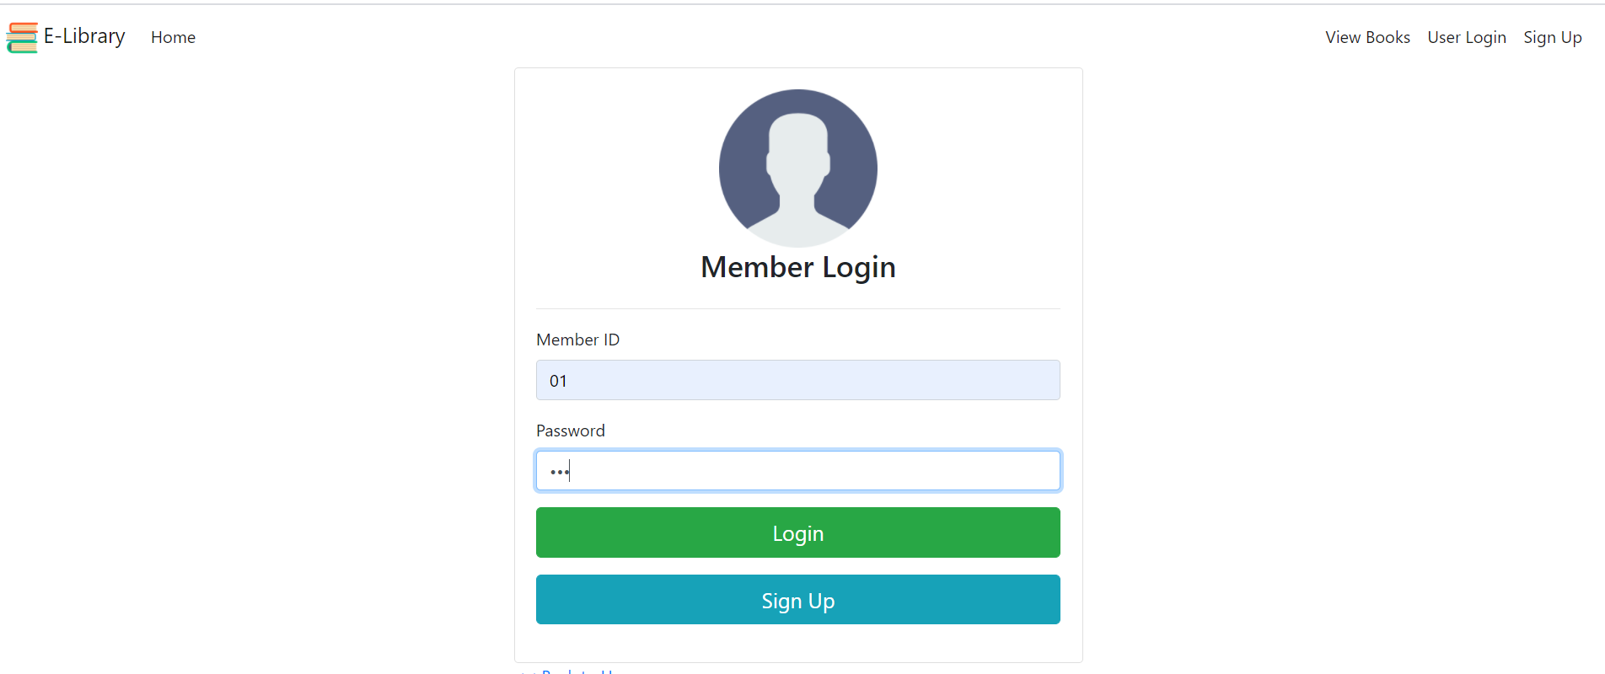

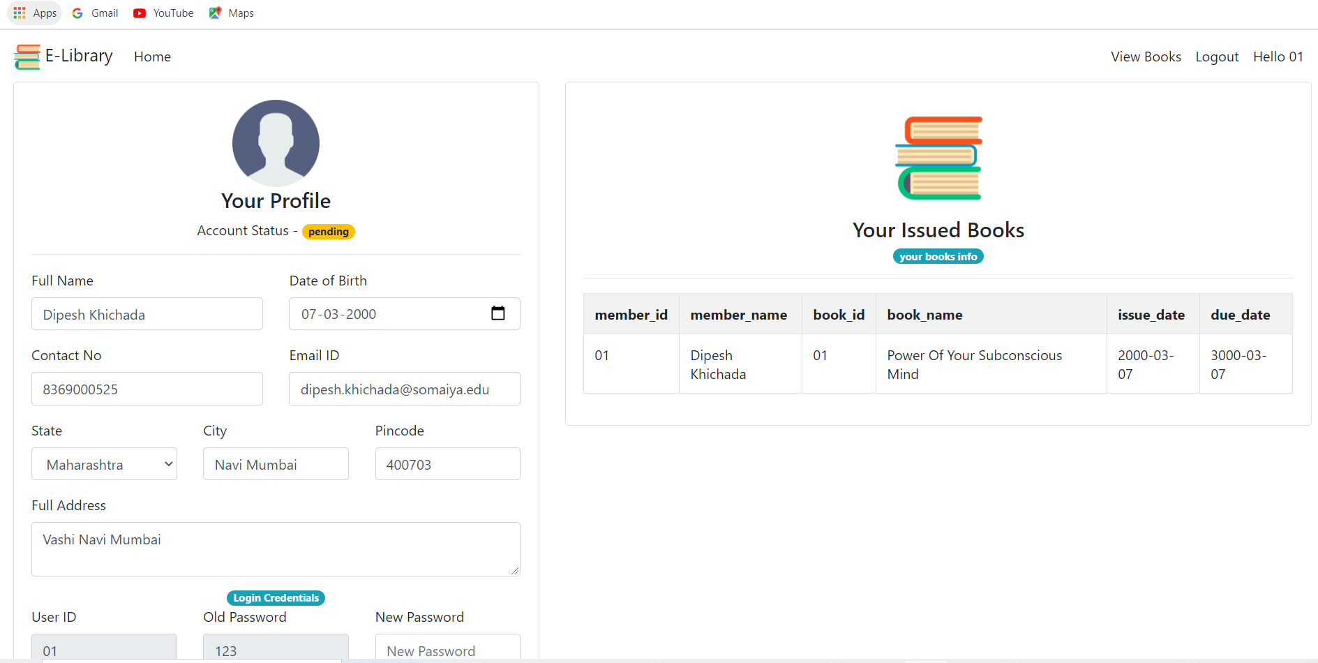

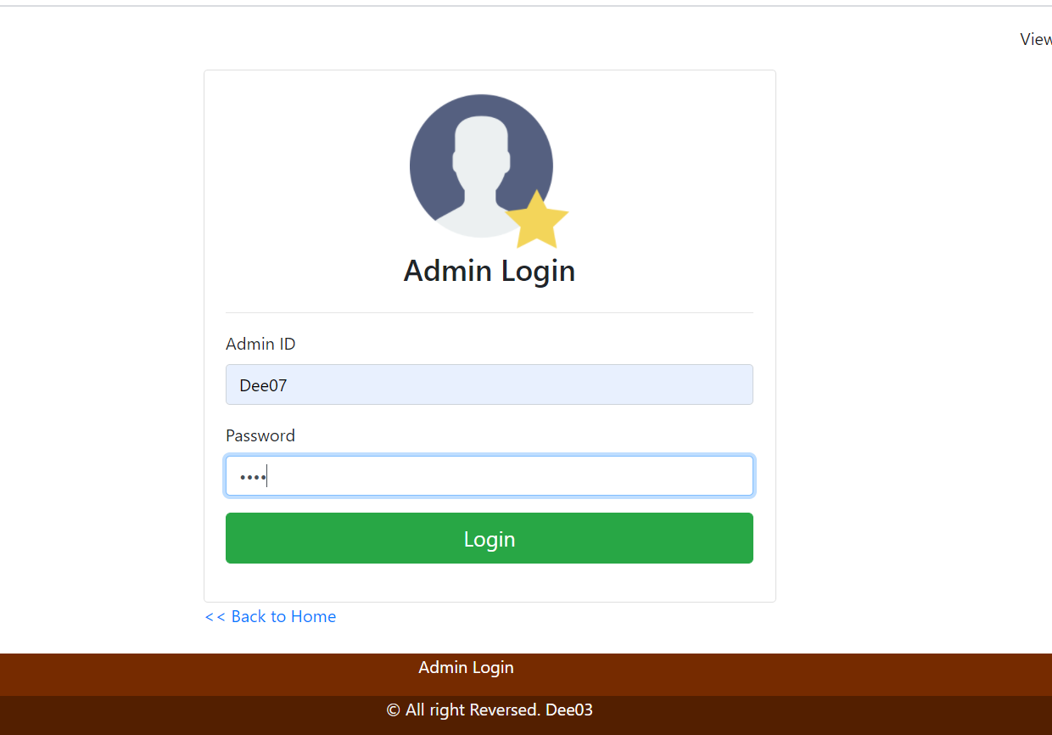

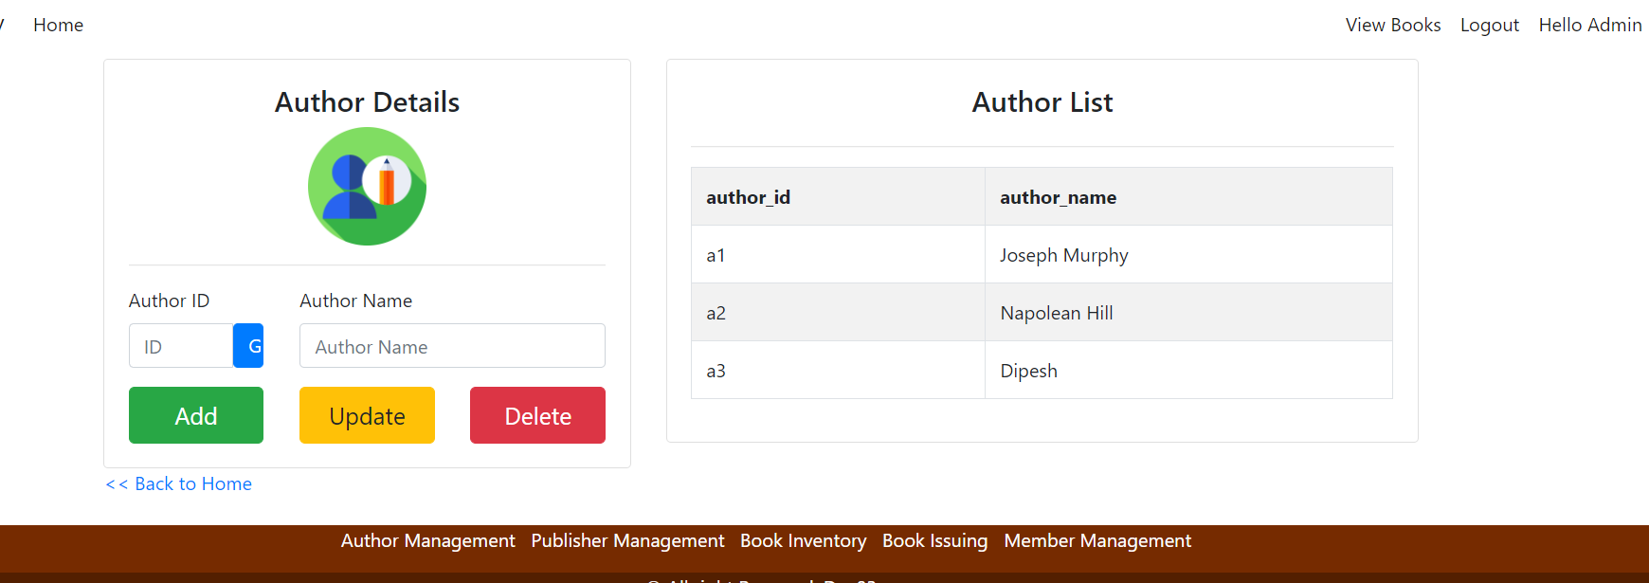

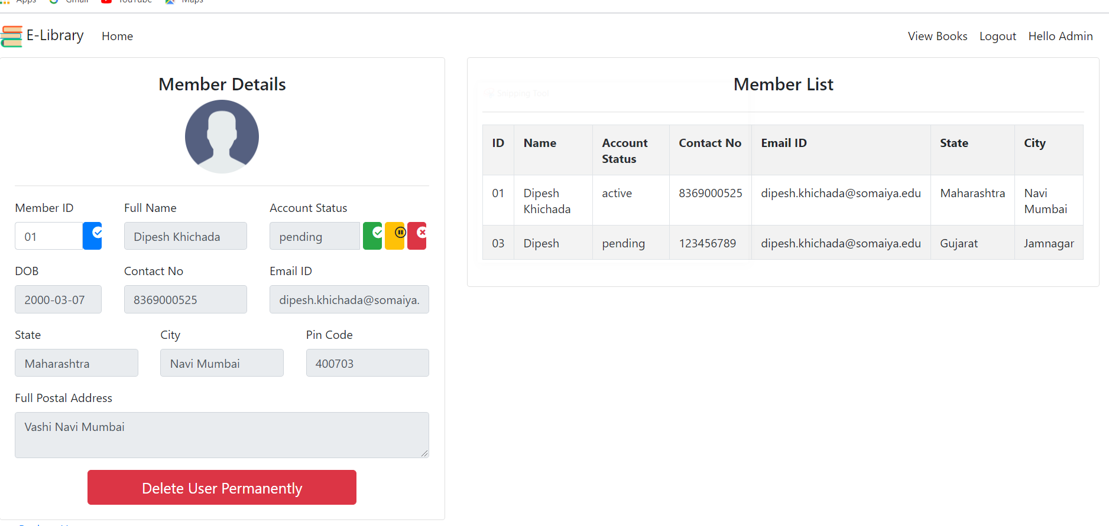

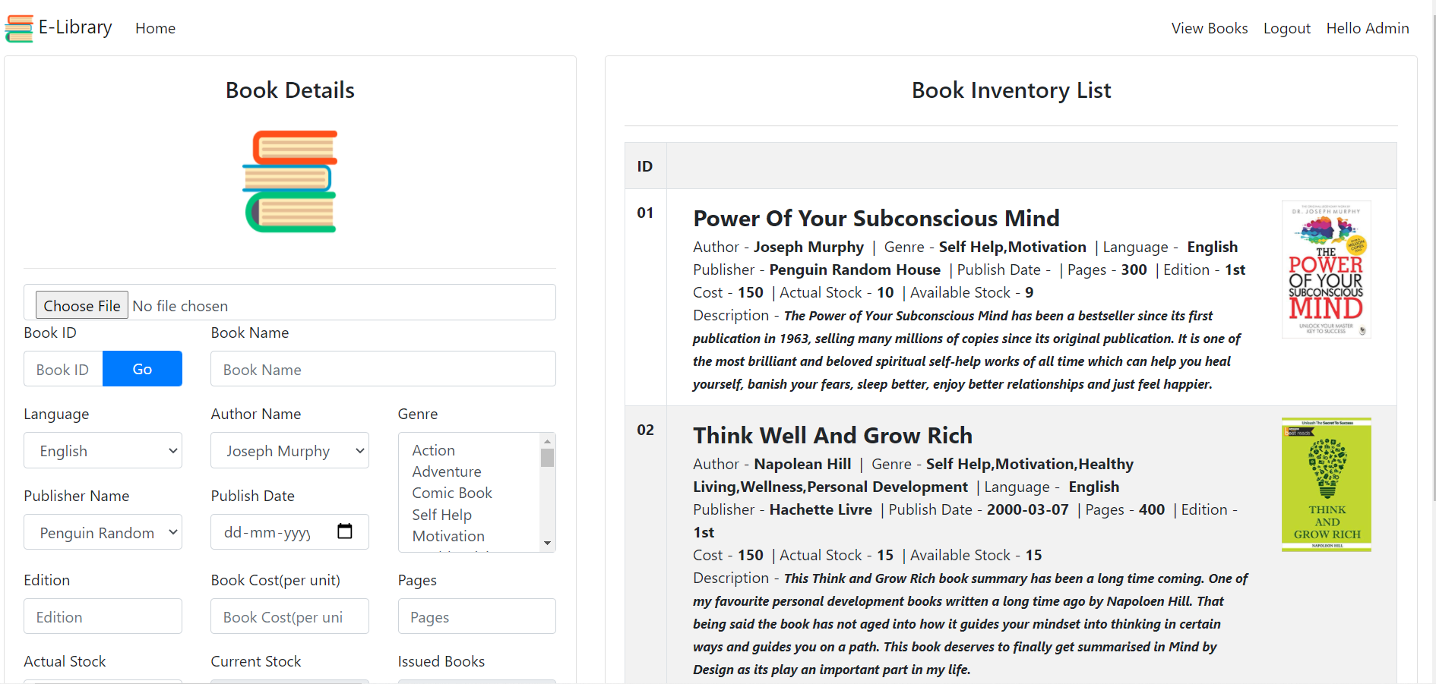

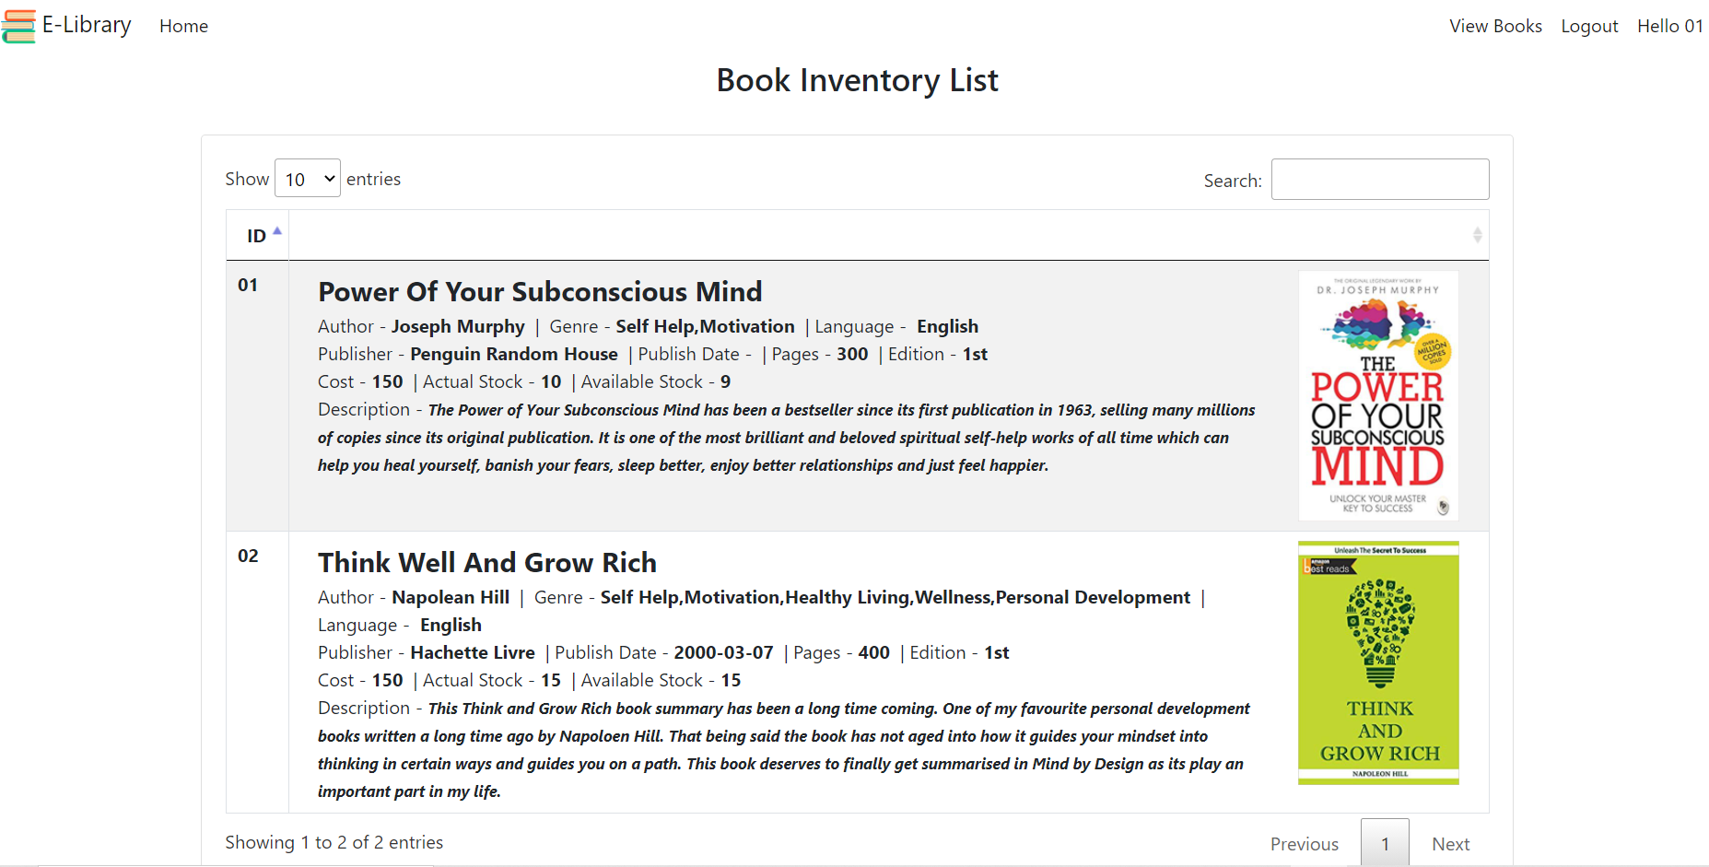

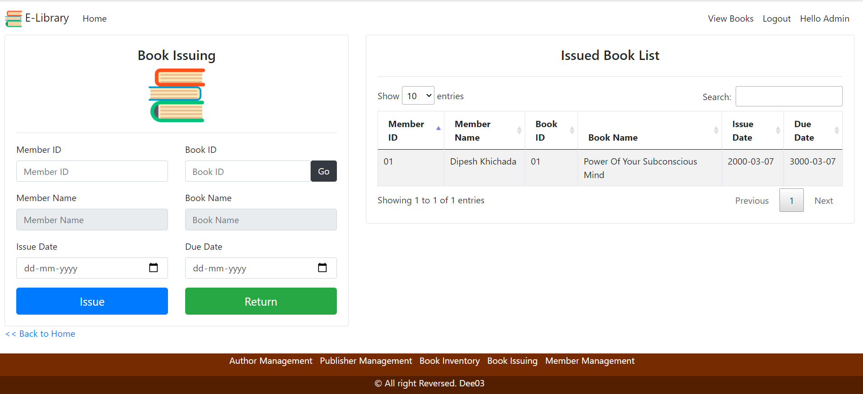

# Future Enhancement

# The feature for getting free pdf to read online so that anyone can access it can be added in view books module.

# Also one can add Review Rating Feature where books can be reviewed.

# Search filter also can be added to get specified result or required.

# Audio Module can be added for keen listener

# Microphone based search technology can be added.

# Download pdf for free books can be made available

# BIBLIOGRAPHY

# 

# [www.geeksforgeeks.org](http://www.geeksforgeeks.org)

# c-sharpcorner.com

# [www.stackoverflow.com](http://www.stackoverflow.com)

# kundavet Tutorial for Asp.Net C#

# Tutorials Point for C#

# Coder baba

# Stackify.com

# Wappalyzer.com

# dotnet.microsoft.com